Project The NFC Uganda Carbon Landscapes Project
Scope: Validation

CAR: Corrective Action Request
CL: Clarification Request
FAR: Forward Action Request

Table 1. Remaining FAR from validation and/or previous verification
FAR ID | 01 | Section no. | From previous Validation Audit Team | Date : DD/MM/YYYY
Description of FAR
The areas reported for the IFM, ARR (conservation), and ARR (out-growers) project instances in the GIS files do not match the areas stated in the Project Description and those applied in the GHG calculations. In addition, the KML files provided include ineligible areas for the proposed project activities, including but not limited to ARR out-grower areas planted prior to the project start date (as early as 2008), unplanted areas, and areas containing buildings, roads, or other infrastructure. While Table 8 has been updated with the correct root-shoot ratio and the applicable reference has been corrected, the calculations spreadsheet has not been consistently updated and continues to apply an incorrect root-shoot ratio in the “CA Non-Forest Summary Results” and “CA Forest Summary Results” sheets.
These inconsistencies create uncertainty in the assessment of the Project Start Date, baseline scenario, additionality, and the quantification of GHG emission removals. Based on the widespread and non-exhaustive instances of ineligible areas identified through independent review, the audit team is unable to reasonably assure the validity of the project area subject to validation and/or verification. Consequently, The Project Proponent shall correct project area delineation, exclude ineligible areas, align GIS/PD/calculations, and update all affected spreadsheets to enable closure of FARID01

Project participant response |  |  |  | Date : DD/MM/YYYY
NA
Documentation provided by project participant
NA
VVB assessment |  |  |  | Date: DD/MM/YYYY
NA

FAR ID | 02 | Section no. | From previous Validation Audit Team | Date : DD/MM/YYYY
Description of FAR
The worksheet “Outgrower Extension Volume Proj.” includes estimates for wood products under both extended rotation and baseline scenarios; however, the underlying assumptions are not sufficiently transparent or verifiable, as sources and references for baseline felling values are not provided. While Sections 5.3 and 7.4 have been updated, no methodology deviation has been identified or justified in Section 3.6 for the five-year rotation extension applied to Eucalyptus grandis, as required under Section 8.6.1 of VM0003, nor has it been demonstrated that this does not negatively affect the conservativeness of GHG quantification in accordance with Section 3.19 of the VCS Standard. In addition, Sections 5.3 and 7.4 do not adequately demonstrate that leakage due to market effects is equal to zero, as required by the methodology.
.

Project participant response |  |  |  | Date : DD/MM/YYYY
NA
Documentation provided by project participant
NA
VVB assessment |  |  |  | Date: DD/MM/YYYY
NA

FAR ID | 03 | Section no. | From previous Validation Audit Team | Date : DD/MM/YYYY
Description of FAR
Section 3.3 has been updated; however, this finding remains pending closure of FARID02, as the matters addressed therein directly affect the assumptions applied in this section. In addition, the justification related to wood products has not been consistently reflected in Table 5. Specifically, the Wood Products row does not include the stated justification and contains statements inconsistent with the explanation provided elsewhere in the document (i.e., “conservatively not included due to monitoring costs”). The Project Proponent shall ensure closure of FARID02 and update Section 3.3 and Table 5 to provide a clear, transparent, and internally consistent justification aligned with the applicable methodology requirements.

Project participant response |  |  |  | Date : DD/MM/YYYY
NA
Documentation provided by project participant
NA
VVB assessment |  |  |  | Date: DD/MM/YYYY
NA

FAR ID | 04 | Section no. | From previous Validation Audit Team | Date : DD/MM/YYYY
Description of FAR
The Project Proponent shall provide further explanations regarding the cited allegations and dispute associated with the project. However, at the time of the assessment conducted by previous VVB, the audit team was unable to independently confirm, through consultation with affected communities, that the dispute resolution process was satisfactory and that no additional grievances, human rights violations, or any form of coercion have occurred as a result of the project’s implementation.
This matter was identified through independent research conducted by the previous audit team after the onsite visit. Consequently, the interviewed stakeholders, including out-grower communities, could not be specifically consulted regarding this dispute during the stakeholder engagement process.
While this does not constitute a non-conformity at this stage, the audit team is unable to reasonably assure full compliance with the AFOLU safeguards requirements under Section 3.19 of the VCS Standard. The PP is therefore requested to ensure that mechanisms are in place to enable verification of satisfactory dispute resolution and continued compliance with AFOLU social safeguard requirements during future monitoring and verification activities

Project participant response |  |  |  | Date : DD/MM/YYYY
NA
Documentation provided by project participant
NA
VVB assessment |  |  |  | Date: DD/MM/YYYY
NA

Table 2. CL from this verification

CL ID | 01 | Section no. | 1.1 | Date : 11/12/2025
Description of CL

Section: 1.1 Summary Description of the Project
Reference:
- VCS PD Template v4.4, Section 1.1 – “Summary description of the technologies/measures to be implemented by the project.
- VCS PD Template v4.4, Section 1.1 – “An explanation of how the project is expected to generate GHG emission reductions or carbon dioxide removals.”
- VCS PD Template v4.4, Section 1.1 – “A brief description of the scenario existing prior to the implementation of the project.”
- VCS PD Template v4.4, Section 1.1 – “Provide a summary description of the project to enable an understanding of the nature of the project and its implementation.”
- VCS PDD Template v4.4, Section 1.1 – “An estimate of annual average and total reductions and removals.”
Issues:
- The PD provides only a general description of the reforestation and out-grower afforestation activities and lacks adequate technical detail on the technologies and silvicultural practices to be applied. Key aspects such as species selection, nursery operations, site preparation, planting density and techniques, maintenance practices, and protection measures are not described. Consequently, the information provided is insufficient to demonstrate a clear and verifiable understanding of the project’s technical implementation.
- While the PD states that carbon sequestration will occur through reforestation and afforestation, it does not adequately explain the underlying GHG removal mechanisms. The document fails to clearly identify the relevant carbon pools, describe the quantification approach for removals, or address key concepts such as permanence and reversal risk at a summary level. As a result, the description is insufficient to demonstrate a transparent and technically sound GHG removal framework.
- The baseline scenario is described only in qualitative narrative form and does not provide sufficient evidence to demonstrate that, without the project, the land would have remained non-forested or continued to degrade. The causal link between historical land use, current conditions, and the proposed without-project scenario is not clearly articulated, limiting the robustness and credibility of the baseline determination.
- The PD presents inconsistent information regarding the role of the Namwasa, Kirinya, and Luwunga commercial plantations, first introducing them as key background elements and later stating that the VCS project excludes commercial plantations. This inconsistency creates ambiguity concerning the actual project scope and the inclusion or exclusion of these areas from GHG accounting, thereby undermining the clarity of the project boundary and eligible activities.
- The PD provides an estimate of total removals (2,795,190 tCO₂e over 40 years) and an annual average (69,880 tCO₂e/year); however, it is not explicitly stated whether these figures represent net VCS-eligible removals after application of AFOLU risk buffers, leakage deductions, or other conservative adjustments.
Required Actions:
- The PP shall revise Section 1.1 of the PDD to include a concise but technically adequate description of the reforestation and afforestation measures, including species used, planting methods, silvicultural regime, site preparation, and long-term forest management practices.
- The PP shall enhance Section 1.1 with a clear and concise explanation of how carbon dioxide removals are generated, including identification of the main carbon pools affected and a summary-level explanation of how permanence and reversal risks are addressed.
- The PP shall revise Section 1.1 to provide a clearer and more explicit description of the without-project scenario, including confirmation that the lands would have remained degraded or non-forest in the absence of the project and a brief justification of why reforestation/afforestation would not have occurred without the project.
- The PP shall clearly and unambiguously define in Section 1.1 which areas and activities are included in the VCS project boundary and explicitly confirm whether commercial plantation areas are excluded from credit generation, ensuring consistent scope throughout the PD.
- The PP shall clarify whether the stated annual and total estimates represent gross or net removals and confirm that the figures are consistent with the methodology, leakage treatment, and AFOLU non-permanence risk buffer application.
Project participant response |  |  |  | Date : DD/MM/YYYY
Documentation provided by project participant
VVB assessment |  |  |  | Date: DD/MM/YYYY

CL ID | 02 | Section no. | 1.9 | Date : 11/12/2025
Description of CL

Section: 1.9 Project start date
Reference:
- VCS Standard v4.7, Section 3.8.3 “All AFOLU projects with ex-ante emission reduction/removal estimates of 20,000 tCO2e per year or less, and ARR, RWE and IFM (with the exclusion of Logged to Protected Forest (LtPF)) projects of any size shall complete validation within eight years of the project start date.” And section 3.8.4 “All other AFOLU projects shall complete validation within five years of the project start date.”
- VCS PD Template v4.4, Section 1.9; VCS Program Rules on Project Start Date
Issue:
- Under VCS Standard v4.7, Section 3.8.3 requires validation within eight years of the project start date for AFOLU projects ≤20,000 tCO₂e/year and ARR projects of any size, while Section 3.8.4 requires validation within five years for all other AFOLU projects. The project’s current annual ex-ante estimate of 69,880 tCO₂e and a start date exceeding eight years demonstrate non-compliance with both Section 3.8.3 and Section 3.8.4, and therefore the project does not meet the applicable validation timeline requirements.
- The PP defines the project start date as 1 July 2017 based on the formalization of the out-grower program. However, the justification also confirms that seedlings were provided to farmers prior to this date, which may have resulted in tree planting and the initiation of carbon stock enhancement before 1 July 2017. The PDD does not explicitly demonstrate that no ARR planting or GHG removals occurred prior to the stated project start date, as required under VCS rules.
- The PP states that seedlings were distributed prior to 1 July 2017 as a “gesture of goodwill,” but the PD does not clearly specify whether these pre-2017 plantings are included within the VCS project boundary or explicitly excluded from all carbon accounting. This lack of clarity creates ambiguity regarding the treatment and eligibility of pre-project planting activities.
Required Action:
- The PP shall provide documented justification demonstrating how the project complies with the requirements of VCS Standard v4.7, Section 3.8.3 or Section 3.8.4, as applicable.
- The PP shall clearly demonstrate that no GHG emission removals claimed under the project occurred prior to 1 July 2017,
- The PP should explicitly confirm that all tree planting conducted prior to 1 July 2017 is excluded from the VCS project boundary and carbon accounting or otherwise revise the start date accordingly.
Project participant response |  |  |  | Date : DD/MM/YYYY
Documentation provided by project participant
VVB assessment |  |  |  | Date: DD/MM/YYYY

CL ID | 03 | Section no. | 3.5.2 | Date : 11/12/2025
Description of CL

Section: 3.5.2 Additionality Methods
Reference:
- VCS PD Template v4.4, Section 3.5.2
Issue:
- The PD uses both investment analysis and barrier analysis, but does not clearly state which method (investment, barrier, performance, or activity method) is formally being used as the primary additionality approach under the tool’s rules.
- While the PD correctly distinguishes between out-grower ARR activities and conservation area reforestation, the financial additionality analysis, barrier analysis, and common practice assessment for each component are interwoven in the narrative. As a result, it is not possible to clearly and independently trace, for each project component, the applicable investment test, the specific barriers, and the corresponding common practice conclusion. This lack of structural separation undermines the transparency and auditability of the component-level additionality demonstration.
Required Action:
- The PP shall explicitly state which additionality method(s) under the applied tool are being used (e.g., project method using investment analysis in combination with barrier analysis and common practice analysis under AR-TOOL-02 and/or VT0001, as applicable) and shall formally confirm that the selected combination of methods is permitted under the applied tool and methodology requirements.
- The PP shall clearly separate the additionality demonstration for the out-grower ARR activities and the conservation area reforestation activities, structuring each component independently through the applicable tool steps (Step 2–4). The revised structure shall enable a clear, stand-alone trace of the investment test, barrier analysis, and common practice conclusion for each project component.
Project participant response |  |  |  | Date : DD/MM/YYYY
Documentation provided by project participant
VVB assessment |  |  |  | Date: DD/MM/YYYY

CL ID | 04 | Section no. | 4.2 | Date : 11/12/2025
Description of CL
Section: 4.2 Project emission
Reference:
- PD Section 4.2 (SOC estimation, Equation 6–7), default values (47 tC/ha, 24.5 tC/ha, cap 0.8 tC/ha/yr) and comment “75% of out-grower area was historically ploughed (aerial observation)”.
Issues:
While the PD cites the AR-TOOL-16 default approach and correctly notes the 0.8 tC/ha/yr cap, the PD lacks reproducible evidence for (a) the initial SOC inputs applied per stratum, (b) the calculation steps to move from reference SOC to initial SOC (i.e., where 24.5 tC/ha comes from), and (c) the evidence and method underpinning the statement that “75% of out-grower area was historically ploughed.” VCS/AR-TOOL-16 requires that if defaults are used the choice must be justified and data sources and calculations must be shown so a verifier can reproduce the SOC change estimates. The aerial observation statement is insufficient as evidence.

Required Actions:
- A worked SOC calculation spreadsheet (per stratum) showing all input values (reference SOC, fLU,i, fMG,i, fIN,i, initial SOC), their sources (table and page numbers from the AR tool), and the numeric steps used to derive the 24.5 tC/ha initial SOC and subsequent rate.
- Evidence supporting the “75% ploughed” figure (e.g., high-resolution imagery interpretation report, field survey results, land-use history records, or a stratified sampling survey). If the 75% is an assumption, provide conservative sensitivity analysis showing the impact of different % ploughed (e.g., 50%, 100%) on ex-ante removals.
- Clarify to which strata the 0.8 tC/ha/yr cap is applied (out-grower only? conservation? both) and provide a year-by-year table of SOC change applied to each stratum for the first 20 years and beyond.

Project participant response |  |  |  | Date : DD/MM/YYYY
Documentation provided by project participant
VVB assessment |  |  |  | Date: DD/MM/YYYY

CL ID | 05 | Section no. |  | Date : 11/12/2025
Description of CL
(i)The VVB believes that the Project Area comprises of both the conservation areas as well as outgrower areas. However, the PP is requested to clarify on the same.

(ii)Under the Data/Parameter titled “Area of project area”, the value applied for both conservation areas and the out-grower program has been mentioned as 3,928.7 hectares(ha) and 3,479 hectares(ha) respectively. If both the conservation areas and out-growers make up the Project Area, the total area comes out to be exactly 7,407.7 hectares(ha). However, upon inspecting the attribute table of the KML File titled Project_Area, it showcases a column titled “area_km_sq” and a value of 7467,202985 sq km. The PP is requested to clarify on the same with complete clarity. Additionally, the VVB conducted their own independent GIS check using the Field Calculator Tool in QGIS for calculating the area. However, it showcased a value of NULL. The PP is requested to clarify on the same.
Project participant response |  |  |  | Date : DD/MM/YYYY
Documentation provided by project participant
VVB assessment |  |  |  | Date: DD/MM/YYYY

CL ID | 06 | Section no. |  | Date : 11/12/2025
Description of CL
The PP has mentioned in Section 5.3.2 of the PD that “A supervised classification of remote sensing data was made to stratify the project area into homogeneous units that have similar carbon stocks.” However, no Supervised Classification Map has been included in the PD showcasing the same. Additionally, the process of stratification has not been explained in complete detail in the PD. The PP is requested to clarify on the same and include this entire information in the PD. Also, the PD mentions that “the non-forest component was further stratified into 13 vegetation classes based on remote sensing as well as field data and the team’s exposure to the area.” However, there is no mention of these 13 vegetation classes in the PD. The PP is requested to include information about these 13 vegetation classes as well in complete detail in the PD.
Project participant response |  |  |  | Date : DD/MM/YYYY
Documentation provided by project participant
VVB assessment |  |  |  | Date: DD/MM/YYYY

CL ID | 07 | Section no. | 5.3 | Date : 11/12/2025
Description of CL
As per section 5.3 of the AR-ACM0003 v2.0 Methodology document, under “Stratification”, it has been explicitly mentioned that “If biomass distribution over the project area is not homogeneous, stratification should be carried out to improve the precision of biomass estimation. Different stratifications may be appropriate for the baseline and project scenarios in order to achieve optimal precision of estimation of net GHG removals by sinks. In particular:

(a)For baseline net GHG removals by sinks, it is usually sufficient to stratify the area according to major vegetation types and their crown cover and/or land use types;

(b) For actual net GHG removals by sinks the stratification for ex ante estimations is based on the project planting/management plan and the stratification for ex post estimations is based on the actual implementation of the project planting/management plan. If natural or anthropogenic impacts (e.g. local fires) or other factors (e.g. soil type) significantly alter the pattern of biomass distribution in the project area, then the ex-post stratification is revised accordingly.”

(i)Now based on the current PD provided to the VVB, it mentions the non-forest component of a map being stratified into 13 vegetation classes. However, there is no inclusion of any stratification map(s) in the PD. The PP is requested to add these stratification maps in the PD.

(ii)The PP is requested to clarify and explain in complete detail on what basis the stratification has been done for their project.

(ii)Also, the PP is requested to mention the names of the 13 vegetation classes based on which the non-forest component of a map was stratified.
Project participant response |  |  |  | Date : DD/MM/YYYY
Documentation provided by project participant
VVB assessment |  |  |  | Date: DD/MM/YYYY

CL ID | 08 | Section no. |  | Date : 11/12/2025
Description of CL
In Section 1.1 of the PD, the PP has explicitly mentioned that “Of the 22,000 ha that NFC manages in Uganda, 40% is set aside as conservation area to protect remaining indigenous forests, rocky outcrops, wetlands and riparian zones as well as areas that are identified as having High Conservation Values, according to FSC(TM).” Numerically, this means that 8,800 hectares(ha) of the NFC managed land in Uganda has been set aside for conservation. There is also a PPT provided to the VVB titled “UG_Tausi_SpatialAnalysis_Sep2025”. This PPT contains the following slide:
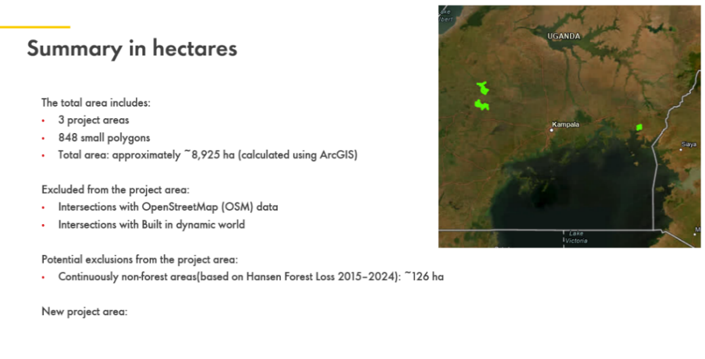

(i)What are the names of these 3 project areas that you are referring to in this slide?

(ii)Was a KML File and Shapefile comprising these 848 small polygons provided to the VVB? The PP is requested to provide the respective vector file(s) to the VVB for assessment.

(iii)The PP is requested to clarify if the total area spoken about here is for the current PAI’s or it also includes future instances. The VVB only requires the KML Files for the current PAI’s.

(iv)The total area which approximates to 8,925 ha (as per this slide), was the corresponding KML and Shapefile provided to the VVB, which justifies this area value? The PP is requested to provide this vector file to the VVB for assessment.

(v)On inspecting the KML File titled “Project_Area”, the VVB found that the KML file comprised of 2 delineated/demarcated Project Area Polygons. The screenshot of the same has been showcased below:
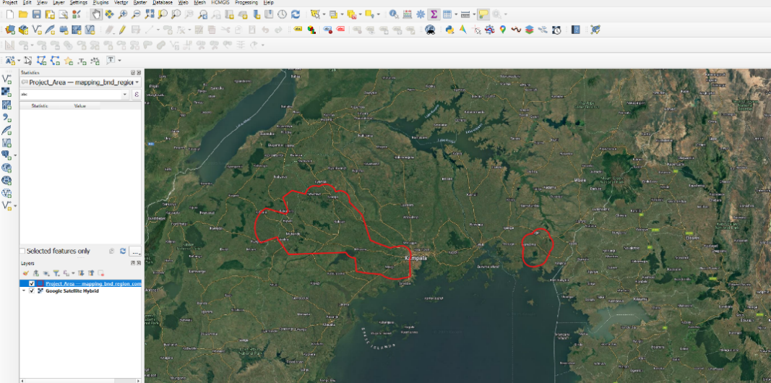

This contradicts the information about the 3 project areas mentioned in the PPT as well as the name assigned to this KML layer that is showcased in this screenshot:

NOTE: The PP is requested to clarify regarding the same and correct the vector files likewise.

(vi)Since the PP has mentioned in the PPT that 8,925 hectares(ha) represents the total area, it clearly indicates that it includes outgrowers and conservation areas. However, if we sum up the conservation area and outgrower area that is mentioned in Section 5.2 of the PD, the total sum comes out to be exactly 7,407.7 hectares(ha). The PP is requested to clarify with complete clarity and depth about the same, since the area values appear to be very inconsistent as of now.

(vii)Also, if the total area of 8,925 hectares(ha) represents the total area of the current PAI, it is imperative for the PP to be definitive about the area value, terms like approximately need to be strictly avoided.

(viii)The PP has provided three separate documents to the VVB inside the folder titled “Non- Forest at start date report and data”: one is a word document detailing the “NFC non-forest report”, the other is a “SpatialAnalysis_Oct2025_Chloris” document, and the third document is a PPT for “SpatialAnalysis_Sep2025”. The PP is requested to explain in complete detail the difference between all three documents.

(ix)The PP has also mentioned in the word document titled “NFC non-forest report” the following:
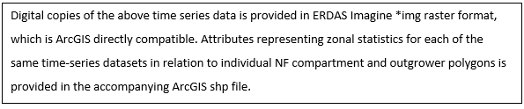

However, the VVB has still not received the *img raster format time series data from the PP. Also, the attributes representing zonal statistics for each of the same time-series datasets in relation to the individual NF compartment and outgrower polygons shapefile as is mentioned in this “NFC non-forest report” document are still awaited from the PP.

(x)The Spatial Analysis for Sep 2025 is in the .pptx format whilst the Spatial Analysis for Oct 2025 is in the .pdf format. The PP is requested to consistently maintain one file format representation, preferably .pdf. Also, the PP is requested to clarify and explain in complete depth the difference between both these documents.
Project participant response |  |  |  | Date : DD/MM/YYYY
Documentation provided by project participant
VVB assessment |  |  |  | Date: DD/MM/YYYY

CL ID | 09 | Section no. |  | Date : 11/12/2025
Description of CL
There were several anomalies/discrepancies found between the PPT and PD. The PP is requested to clarify regarding the following with complete depth and clarity:

Sl.No | Finding | Evidence
1 | Hansen data unreliability for Ugandan dry forests not addressed – The PPT explicitly states Hansen Global Forest Change is “uncertain” and “data quality is not suitable” for the project area, yet the PD relies on Hansen-derived non-forest proof (2015–2024) for outgrower eligibility without justification or alternatives. | “Hansen has known limitations in tropical dry forest regions”; “126 ha continuous non-forest not excluded due to inaccuracy”. PD Section 1.4, Section 4.2 claims non-forest baseline using similar data without caveats.
2 | Dynamic World built-up exclusions not incorporated into PD boundary – The PPT excludes ~100 ha built-up, but the PD does not apply these exclusions or update the project area, leading to over-estimation of eligible land. | “~100 ha classified as built-up 2025… these areas are currently extracted”. PD Section 1.12 includes full area without exclusions.
3 | OSM intersections (roads/buildings) minimized but not verified in PD – The PPT excludes minimal OSM (~2 ha), but the PD does not verify or incorporate this, risking ineligible infrastructure in the boundary. | “382 buildings <2 ha; 270 polygons intersect roads”. PD no mention.

NOTE: The PP is requested to clarify, confirm and explain in-depth regarding all the above-mentioned anomalies/discrepancies.
Project participant response |  |  |  | Date : DD/MM/YYYY
Documentation provided by project participant
VVB assessment |  |  |  | Date: DD/MM/YYYY

CL ID | 10 | Section no. |  | Date : 11/12/2025
Description of CL
There were several anomalies/discrepancies found between the Chloris PDF and PD. The PP is requested to clarify regarding the following with complete depth and clarity:

Sl. No | Finding | Evidence
1 | Chloris data shows >99% forest cover since 2007 – The PDF concludes >99% of the screened area is forest from 2007, contradicting the PD's non-forest baseline at project start (2017). No reconciliation or AGB threshold application in PD. | PDF: “>99 % classified as forest since 2007”; “discrepancies with satellite imagery”. PD Section 4.2 assumes zero tree cover baseline.
2 | Partial Chloris coverage not disclosed or resolved – The PDF notes Chloris “only partially covers the area of interest”, but the PD uses incomplete data for eligibility without addressing gaps or alternatives. | PDF: “Chloris is just partly covering… therefore not used in full”. PD no disclosure.
3 | Sensitivity to AGB thresholds not analyzed in PD – The PDF recommends AGB >250 tCO2/ha for forest classification and notes “binary classification risks over-foresting degraded plots”, but PD uses simplistic baseline without threshold sensitivity. | PDF: “Sensitivity to thresholds”; “overestimation in agroforestry”. PD no analysis.

NOTE: The PP is requested to clarify, confirm and explain in-depth regarding all the above-mentioned anomalies/discrepancies.
Project participant response |  |  |  | Date : DD/MM/YYYY
Documentation provided by project participant
VVB assessment |  |  |  | Date: DD/MM/YYYY

CL ID | 11 | Section no. |  | Date : 11/12/2025
Description of CL
There were several anomalies/discrepancies found between the NFC non-forest report and the PD. The PP is requested to clarify regarding the following with complete depth and clarity:

Sl. No | Finding | Evidence
1 | Significant tree cover in 2000 not accounted for in PD baseline – The report shows high tree cover in 2000, loss 2005–2010, and assumes re-planting of cleared indigenous areas, but PD assumes zero baseline without addressing historical forest. | Report: “Significant tree content in 2000”; “bulk of clearing 2005–2010”. PD Section 4.2 assumes zero.
2 | Inability to distinguish indigenous vs. planted cover – The report admits GFW datasets “do not discriminate between indigenous and planted timber”, but PD treats all woody cover as ARR-eligible without separation. | Report: “Cannot be categorically confirmed”. PD no distinction.
3 | NDVI thresholds for 2005 not validated – The report uses NDVI-modelled 2005 data showing similarity to 2000, but PD does not validate or use these thresholds for eligibility. | Report: “NDVI threshold values used”. PD no mention.

NOTE: The PP is requested to clarify, confirm and explain in-depth regarding all the above-mentioned anomalies/discrepancies.
Project participant response |  |  |  | Date : DD/MM/YYYY
Documentation provided by project participant
VVB assessment |  |  |  | Date: DD/MM/YYYY

CL ID | 12 | Section no. |  | Date : 11/12/2025
Description of CL
The PP is requested to do the following:

(i)Provide the Uganda country Boundary KML file to the VVB since the PD clearly showcases the Project Area lying within the Project Boundary for the ease of geospatial visualization from the VVB’s side.

(ii)On conduction of the GIS Overlay Analysis for the provided KML File titled “Project_Area” with the supposed Project Area KML Files of various other VCS Projects, a potential GIS Overlay/Overlap was found to occur for the following projects:

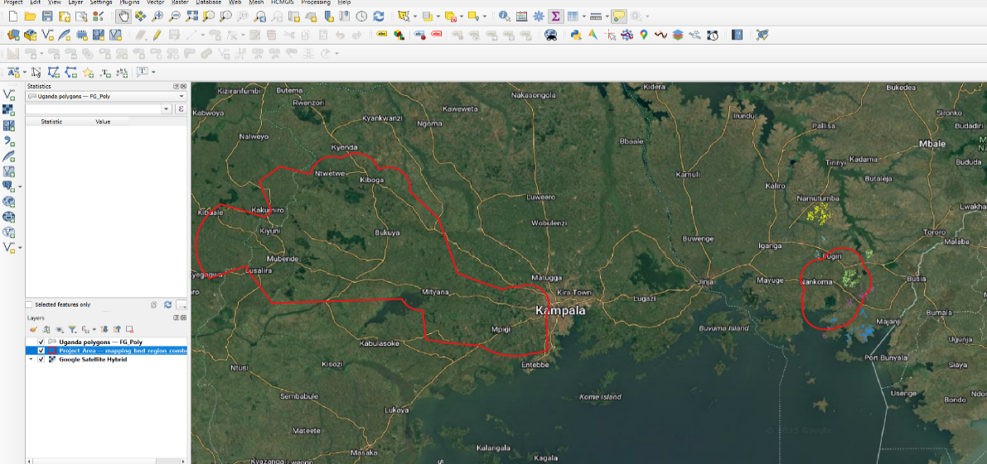
Case 1: VCS ID: 5483: Lake Victoria Watershed Agroforestry Carbon Project II

Figure 1
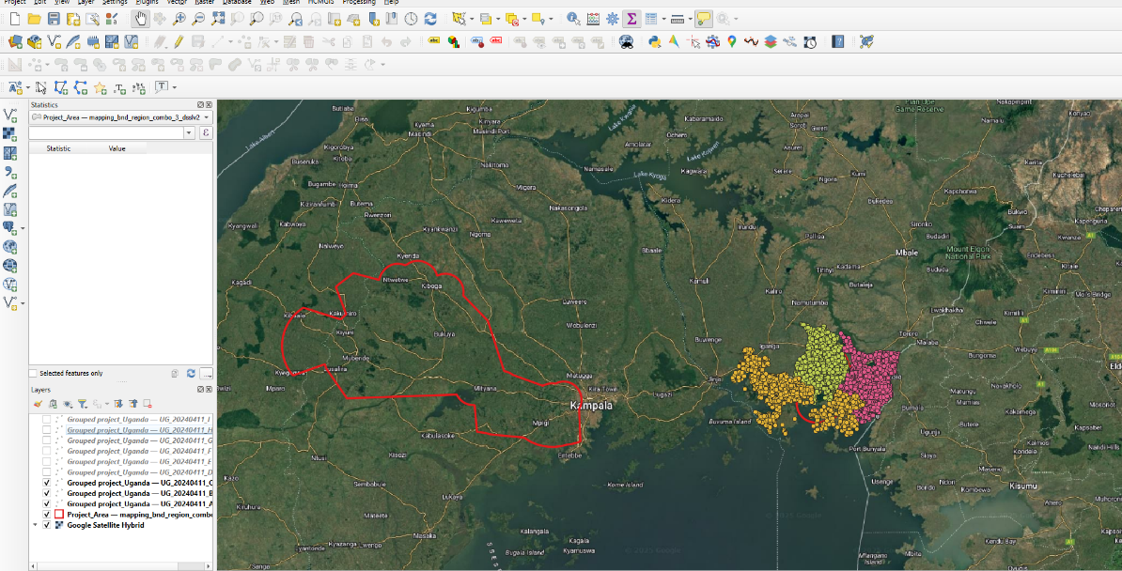
Case 2: VCS ID:5114: Grouped Projects for Safe Water Program in Uganda

Figure 2

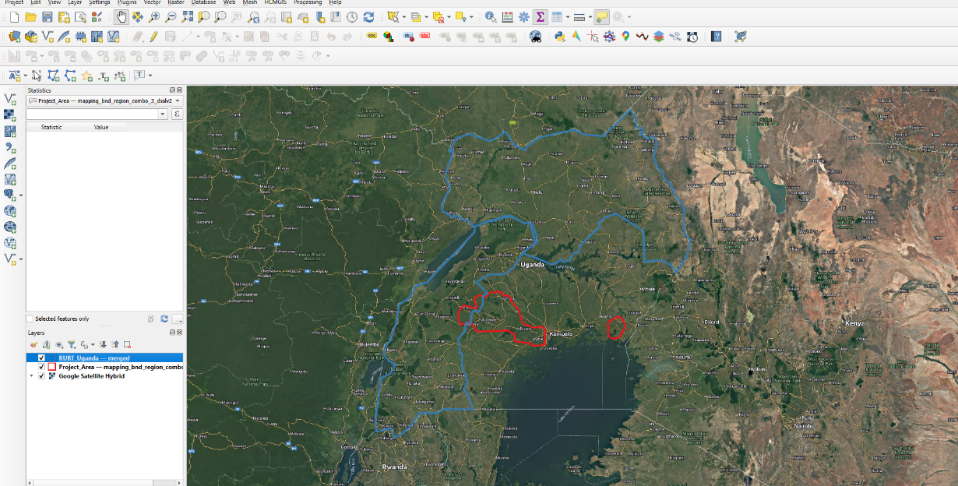
Case 3: VCS ID:4888: OYU - Reforesting Uganda for a better tomorrow

Figure 3
However, as per Section 3.11.3 of the VCS Standard v4.7, it has been explicitly mentioned in that document that “The project area shall not overlap with the project area of another VCS AFOLU project.” However, in the screenshots incorporated above, potential overlaps are very vividly visible. The PP is requested to clarify on the same in complete detail and with complete justification. Also, the PP is requested to ensure that these overlaps are not visible across Project Areas of various other registries as well, like: Gold Standard (GS), The American Carbon Registry (ACR),BioCarbon Standard (BCR),etc. Additionally, the PP is also requested to ensure that Section 3.11.3 of the VCS Standard v4.7 is adhered to and not violated. The PP is also requested to provide concrete physical evidence to the VVB to indicate no overlap of the Project Area of this project with that of other VCS AFOLU projects as well as other carbon registries.
(v)The PP is requested to clarify and confirm regarding the following:
(a)Difference between Conservation Areas and Outgrowers.
(b)Whether Conservation Areas and Outgrowers together make up the Project Area.
(c)If the Conservation Areas and Outgrowers together make up the Project Area, then why is it that the KML File titled “Project_Area” comprises of Non-Eligible Areas like roads, waterways, settlements, water bodies,etc why are not in compliance with Section 3.11.2(3)(c)of the VCS Standard v4.7.
Project participant response |  |  |  | Date : DD/MM/YYYY
Documentation provided by project participant
VVB assessment |  |  |  | Date: DD/MM/YYYY

CL ID | 13 | Section no. |  | Date : 11/12/2025
Description of CL
(i)Upon inspection of the “Project_Area” KML File, it was found that it comprised of two major delineated/demarcated polygons. And if we go as per Section 3.11.2(c) of the VCS Standard v4.7, non-eligible areas such as roads, settlements, waterways, water bodies etc. are clearly visible. Some of the screenshots for the same are as represented below:
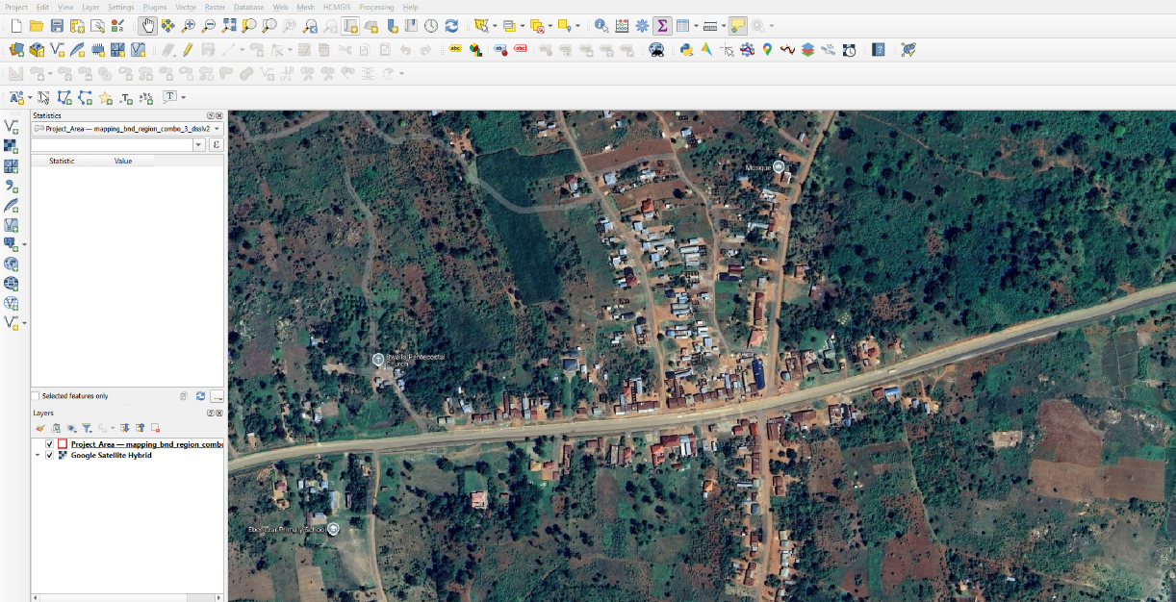

Figure 1

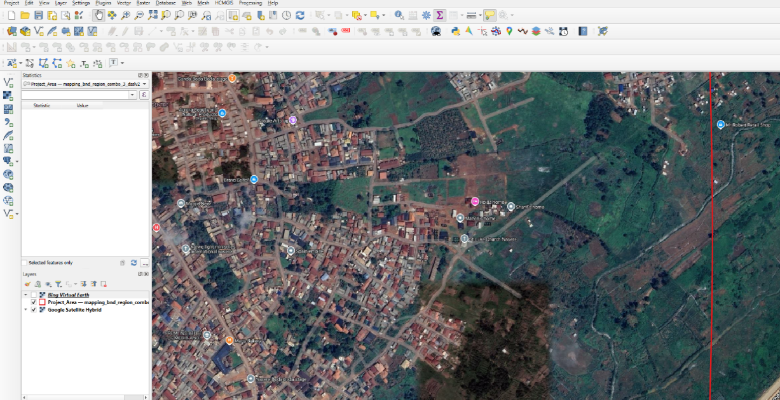

Figure 2

(ii) The PP has provided a KML File titled “Outgrowers_Boundaries”, and a Shapefile titled “202511104_ug_OG_PD(Final)”. The PP is requested to explain the difference between these two vector files and explain in complete detail as to what each of these vector files individually represent.

(iii) The PP is requested to clarify and confirm regarding the following:

(a)Difference between Conservation Areas and Outgrowers.

(b)Whether Conservation Areas and Outgrowers together make up the Project Area.

(c)If Conservation Areas and Outgrowers together make up the Project Area, then why is it that the KML File titled “Project_Area” comprises of Non-Eligible Areas like roads, waterways, settlements, water bodies, etc. which are again not in compliance with Section 3.11.2(3)(c) of the VCS Standards v4.7.

(d)On inspecting the attribute table of the Conservation Areas Shapefile, the VVB observed that there were 19 classes, and the PD does not mention regarding all these 19 classes in the PD. The PP is requested to clarify and explain in-depth regarding what these 19 classes really represent and mention their names along with what they represent/their functionality in the PD.

(e)On summing up the Total Area for the Conservation Areas Shapefile, the VVB observed that the total area came out to be exactly 8751.06 hectares(ha), however there is no mention of this area in the PD.

(f)Additionally, this shapefile was found to comprise of the following Topological Errors:

Case 1: Gaps
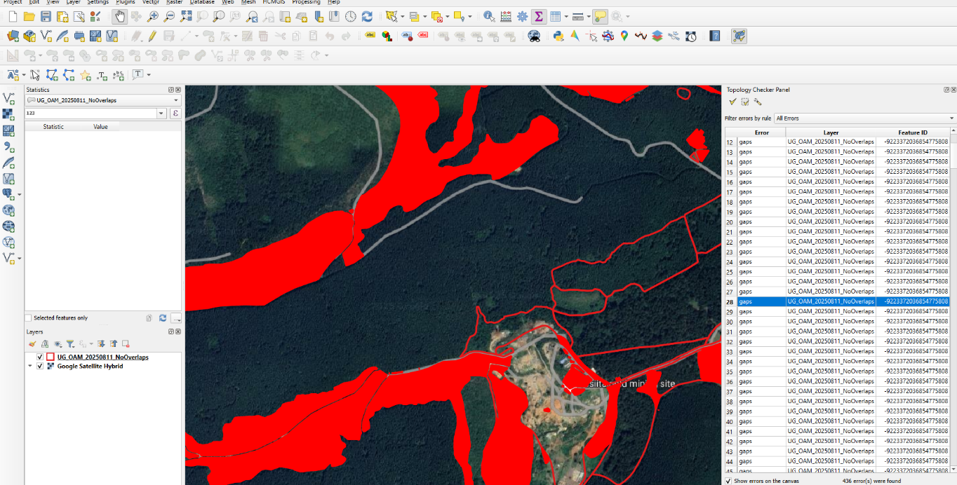

Figure 1

Case 2: Invalid Geometry
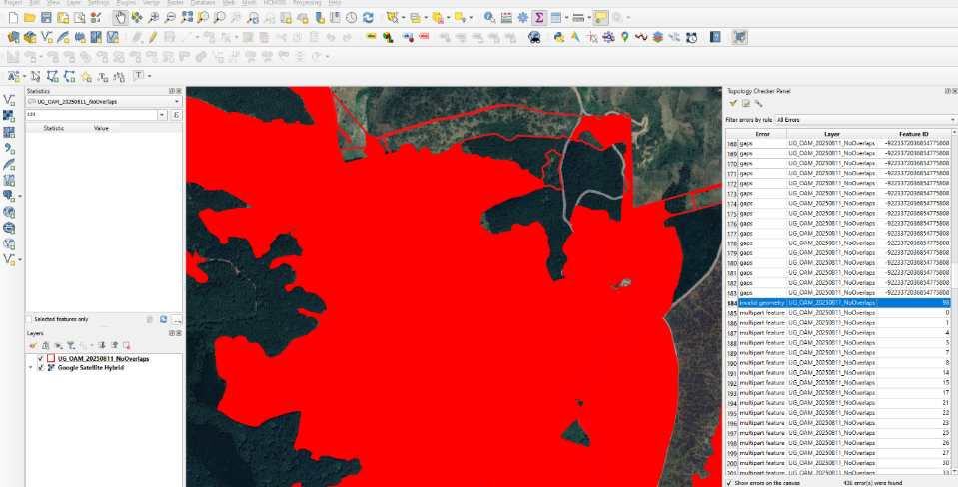

Figure 2

Case 3: Multipart Feature
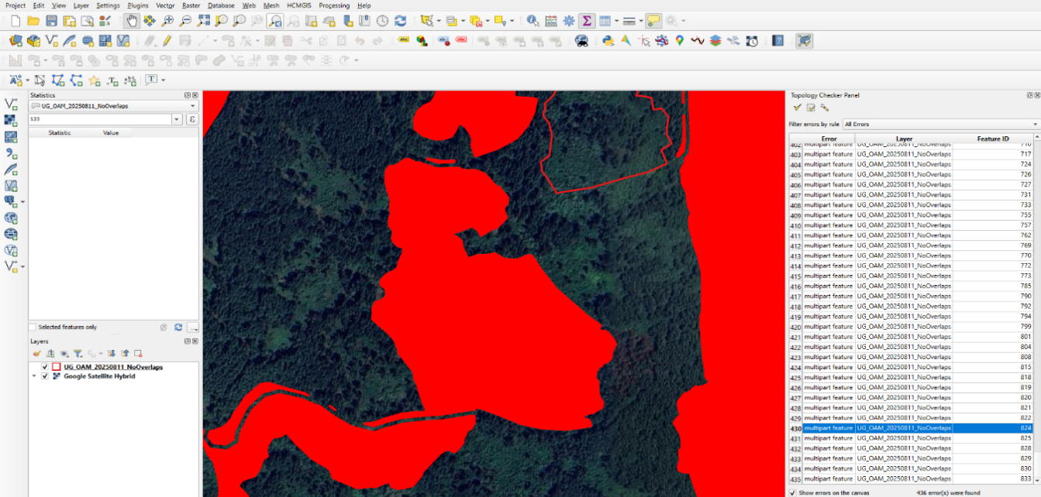

Figure 3

(h)Similarly, the VVB computed the Area of the Outgrowers Shapefile. On conduction of this GIS Assessment, the VVB observed that the total area came out to be exactly 1306.28 hectares(ha), whilst there is a column name mentioned “AREA_HA” in the attribute table, which showcase an area of 1305.14 hectares(ha). There is a difference of exactly 1.14 hectares(ha) between the area that comes on conduction of the GIS Assessment of the provided Shapefile and the area that comes on summing up the “AREA_HA” column of the provided Shapefile. The PP is requested to ensure that the numerical area values across all geospatial evidence and the provided documentation remains accurate and consistent.

(i)On conduction of the GIS Assessment by the VVB, the Outgrowers Shapefile was found to comprise several Topological Errors. The sample screenshots of the same have been showcased below:

Case 1: Gaps
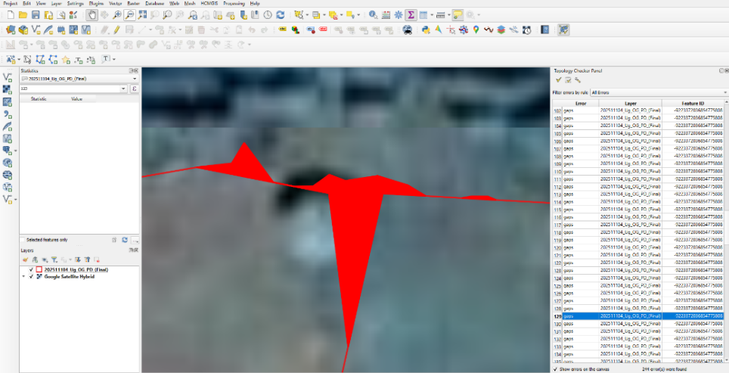

Figure 1
Case 2: Invalid Geometry
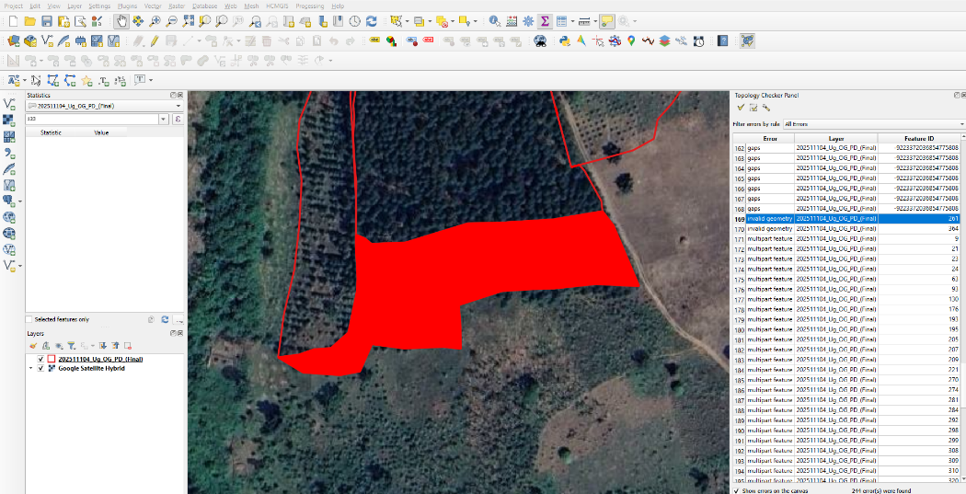

Figure 2

Figure 2

Case 3: Multipart Feature
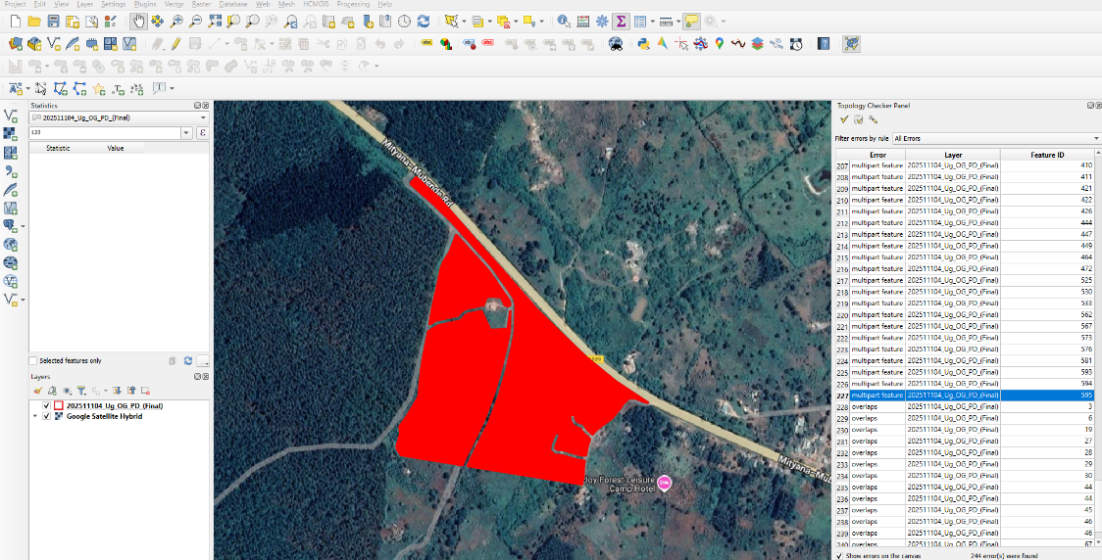

Figure 3

Case 4: Overlaps
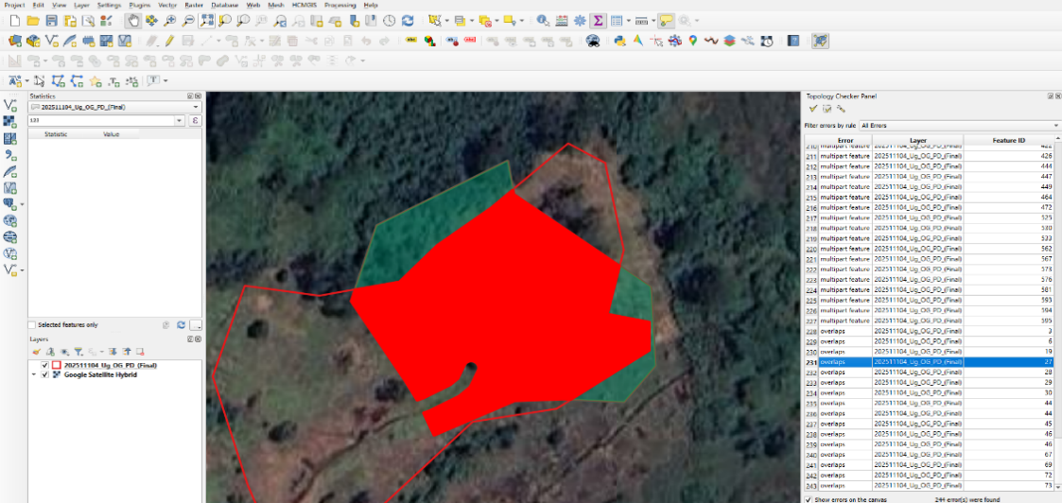

Figure 4

Project participant response |  |  |  | Date : DD/MM/YYYY
Documentation provided by project participant
VVB assessment |  |  |  | Date: DD/MM/YYYY

CL ID | 14 | Section no. |  | Date : 11/12/2025
Description of CL
(i)Upon inspecting the Conservation Areas Shapefile, the VVB observed that some of the classification types mentioned have not been mentioned in the PD. The PP is requested to ensure that all the mentioned information in the PD as well as every other supporting documentation remains consistent.

(ii)The PP has also provided Land Cover Strata Maps as PDF documents. The PP is requested to clarify on what each of these maps truly represents. Also, for the sake of visualization, this is acceptable, however for a geospatial QA/QC check, a TIFF/GeoTIFF file is usually asked for. Additionally, the classifications indicated in the legend of these strata maps are entirely different. The PP is again requested to ensure that all supporting evidences provided must be consistent with the PD.

(iii)The PP has also provided the VVB with jpg image maps of the community association areas. The PP is requested to provide other raster file formats of these maps like TIFF/GeoTIFF (if any).

(iv)The excel file titled “202511104_Ug_OG_PD(Final)” also includes the mention of Regions like Bugiri, Kiboga and Mubende. However, the corresponding geospatial file provided has no mention of these regions. Additionally, the regions mentioned in the PD also include regions that are not a part of this excel file. The PP is requested to ensure consistency across all documentation and supporting evidence.

(v)The PP is requested to clarify if their Project Area comprises of both Outgrowers and Conservation Areas. Also, the PP is requested to explain the term “Outgrowers” in complete detail.

(vi)The PP is requested to explain in complete detail the applicability of conservation areas for the validation only scope, since conservation areas usually indicate a CCB aspect as well. Also, the PP is requested to clarify regarding the methodology and its version number implemented in this project and indicate the same in the PD as well as any other supporting documentation.
Project participant response |  |  |  | Date : DD/MM/YYYY
Documentation provided by project participant
VVB assessment |  |  |  | Date: DD/MM/YYYY

CL ID | 15 | Section no. | 1.12.1 | Date : 11/12/2025
Description of CL
In Section- 1.12.1
Issue-
The PDD states that “Uganda has a National UN-REDD Program and has submitted its first FREL to the UNFCCC in 2018.” However, the PDD does not provide any substantiation or supporting evidence explaining how this national REDD+ context relates to the project activity.
Action Taken-
The Project Proponent must substantiate the statement.
Project participant response |  |  |  | Date : DD/MM/YYYY
Documentation provided by project participant
VVB assessment |  |  |  | Date: DD/MM/YYYY

CL ID | 16 | Section no. | OSV | Date : 26/12/2025
Description of CL
Issue:
The PD declares 1 July 2017 as the project start date. However, during the site visit, interactions with out-grower farmers and UTGA representatives indicated that plantation activities under the carbon project largely commenced during 2020–2023, with farmer agreements executed between 2021–2023, and conservation area planting reported to have begun only in September 2025. This reflects a discrepancy between the declared project start date and the actual timing of implementation activities relevant to the VCS program and methodology requirements.
Action Required:
The Project Proponent is requested to clarify and substantiate the declared project start date of 1 July 2017 with credible, verifiable evidence and reconcile it with the activity timeline observed during the site visit. If necessary, the PP should revise the project start date, crediting period, and grouped project instance inclusion timeline to ensure alignment with the VCS Standard and the applied methodology requirements.

Project participant response |  |  |  | Date : DD/MM/YYYY
Documentation provided by project participant
VVB assessment |  |  |  | Date: DD/MM/YYYY

CL ID | 17 | Section no. | OSV | Date : 26/12/2025
Description of CL
Issue:
During the site visit and based on discussions with government authorities (Forest Department, NFA) and the NFC Forestry Manager, it was noted that conservation of a portion of industrial land as natural forest is a mandatory regulatory requirement. Therefore, the proposed conservation and protection component does not demonstrate regulatory surplus. Further, such conservation/protection activities do not qualify as ARR activities under the applied methodology, and no justification has been provided for additionality in this context.
Action Required:
The PP shall provide justification and supporting evidence to demonstrate regulatory surplus and methodological eligibility of the conservation and protection activities, and clarify how additionality is achieved in alignment with applicable methodology and program requirements.

Project participant response |  |  |  | Date : DD/MM/YYYY
Documentation provided by project participant
VVB assessment |  |  |  | Date: DD/MM/YYYY

CL ID | 18 | Section no. | OSV | Date : 26/12/2025
Description of CL
Issue:
During the site visit, interactions with the PP and participating farmers indicated that harvesting of planted trees is permitted; however, no systematic or documented harvesting plan was provided. Farmers reported harvesting trees planted in 2017 during 2020 with replanting in 2021, and cut stumps were observed in plantation areas. These practices raise concerns regarding permanence of GHG removals. Additionally, Long-Term Average (LTA) carbon stock has not been applied for ex-ante estimation as required for harvested ARR systems.

Action Required:
The PP shall provide documented evidence of harvest management planning, demonstrate how permanence of carbon stocks is ensured, and apply/justify the use of Long-Term Average (LTA) carbon accounting in line with the applied methodology, supported with appropriate documentation.

Project participant response |  |  |  | Date : DD/MM/YYYY
Documentation provided by project participant
VVB assessment |  |  |  | Date: DD/MM/YYYY

CL ID | 19 | Section no. | OSV | Date : 26/12/2025
Description of CL
Issue:
During the site visit, interactions with the PP and participating farmers indicated that harvesting of planted trees is permitted; however, no systematic or documented harvesting plan was provided. Farmers reported harvesting trees planted in 2017 during 2020 with replanting in 2021, and cut stumps were observed in plantation areas. These practices raise concerns regarding permanence of GHG removals. Additionally, Long-Term Average (LTA) carbon stock has not been applied for ex-ante estimation as required for harvested ARR systems.

Action Required:
The PP shall provide documented evidence of harvest management planning, demonstrate how permanence of carbon stocks is ensured, and apply/justify the use of Long-Term Average (LTA) carbon accounting in line with the applied methodology, supported with appropriate documentation.

Project participant response |  |  |  | Date : DD/MM/YYYY
Documentation provided by project participant
VVB assessment |  |  |  | Date: DD/MM/YYYY

CL ID | 20 | Section no. | OSV | Date : 26/12/2025
Description of CL
Issue:
During the site visit, participating farmers reported that existing trees were felled or cleared prior to establishing plantations under the carbon project, and cut stumps were observed by the audit team in several plantation areas. Such practices may be inconsistent with ARR eligibility requirements, as project activities are not permitted on areas where existing trees are cleared and subsequently replanted.

Action Required:
The PP shall clarify this practice and submit documented evidence demonstrating that the project areas meet ARR eligibility criteria in accordance with the VCS Standard and the applied methodology.

Project participant response |  |  |  | Date : DD/MM/YYYY
Documentation provided by project participant
VVB assessment |  |  |  | Date: DD/MM/YYYY

CL ID | 21 | Section no. | OSV | Date : 26/12/2025
Description of CL
Issue:
The PP has declared a project start date of 1 July 2017; however, during interactions with participating farmers it was confirmed that they became aware of the carbon project only during 2020–2021. Further, no evidence was provided to demonstrate that Free, Prior and Informed Consent (FPIC) or stakeholder consultation processes were undertaken during project design and prior to implementation.

Action Required:
The PP shall provide clarification and submit supporting documentation demonstrating compliance with FPIC and stakeholder consultation requirements in accordance with the VCS Standard.

Project participant response |  |  |  | Date : DD/MM/YYYY
Documentation provided by project participant
VVB assessment |  |  |  | Date: DD/MM/YYYY

CL ID | 22 | Section no. | OSV | Date : 26/12/2025
Description of CL
Issue:
During the site visit, affected community members stated that earlier land-related concerns were mutually resolved; however, a public comment indicates that a related legal case remains pending, and PP could not provide documentary evidence confirming formal resolution or dismissal. No evidence was provided to demonstrate that public comments were formally addressed.

Action Required:
The PP shall provide verifiable legal documentation confirming the current status of the case and submit evidence demonstrating that concerns raised through the public comment process have been formally addressed in line with applicable program requirements.

Project participant response |  |  |  | Date : DD/MM/YYYY
Documentation provided by project participant
VVB assessment |  |  |  | Date: DD/MM/YYYY

Table 3. CAR from this verification

CAR ID | 01 | Section no. | 1.4.1 | Date : 11/12/2025
Description of CAR

Section: 1.4.1 General eligibility
Reference:
- VCS PD Template v4.4, Section 1.4.1 – Scope of eligible project activities
- VCS PD Template v4.4, Section 1.4.1, Bullet 2 – “Provide information to demonstrate that the project meets requirements related to the pipeline listing deadline, the opening meeting with the validation/verification body, and the validation deadline.”
- VCS PD Template v4.4, Section 1.4.1, Bullet 3 – “Demonstrate that the applied methodology is eligible under the VCS Program… demonstrate that the project is not a fragmented part of a larger project… and that no single cluster exceeds capacity limits.”
- VCS PD Template v4.4, Section 1.4.1, Bullet 4 – “Include any other relevant eligibility information.”
Issues:
- The PP states that the project “fulfils the requirements of ARR activities within the AFOLU project category” but does not explicitly justify how the project meets AFOLU ARR eligibility criteria.
- Although the PP states that the project was listed on 11 November 2022 and that an exemption was granted on 1 July 2025 to complete validation by 30 June 2027, the PDD does not disclose the project start date for assessment against applicable pipeline requirements, mention about formal opening meeting with the VVB. Therefore, compliance with pipeline and validation deadlines is not adequately demonstrated.
- The PD states that CDM AR-ACM0003 v2.0 is applied but does not demonstrate that the methodology is approved and eligible for use under VCS at the time of validation, nor does it identify applicable scale or capacity limits. Additionally, the PD does not demonstrate that the project is not a fragmented component of a larger activity or that no cluster exceeds capacity limits despite multiple project components. This represents a material eligibility gap.
- The PP states that the project is eligible based on “including several Kyoto Protocol greenhouse gasses (GHGs) particularly carbon dioxide (CO₂).” However, ARR projects typically involve only CO₂ removals, and no justification is provided for inclusion of multiple GHGs. This statement is misleading and unsupported.
- The PP states that the project does not violate any applicable law and refers to Section 1.15, but no summary-level legal eligibility confirmation is provided in this section itself, as required for general eligibility screening.
Required Action:
- The PP should include a brief but explicit justification confirming that the project meets AFOLU ARR eligibility criteria, including confirmation of forest definition compliance and land-use eligibility timing.
- The PP shall provide the project start date and date of the formal opening meeting with the VVB.
- The PP shall confirm the formal VCS approval status of AR-ACM0003 v2.0, declare any applicable scale or capacity limits, demonstrate that the project is not a fragmented component of a larger activity, and confirm that no project cluster exceeds applicable capacity thresholds.
- The PP should clarify which specific GHGs are included in the project boundary and correct the statement if only CO₂ removals are applicable.
- The PP should provide a summary confirmation of legal eligibility directly in Section 1.4.1, referencing the most relevant regulatory approvals or land tenure authorizations.
Project participant response |  |  |  | Date : DD/MM/YYYY
Documentation provided by project participant
VVB assessment |  |  |  | Date: DD/MM/YYYY

CAR ID | 02 | Section no. | 1.4.2 | Date : 11/12/2025
Description of CAR
Section: 1.4.2 AFOLU project eligibility

Reference:
- VCS PD Template v4.4, Section 1.4.2, Bullet 1 – “Justify and demonstrate that all selected AFOLU project categories are appropriate and that all related category requirements are met.”
- VCS PD Template v4.4, Section 1.4.2, Bullet 2 – “Provide evidence that native ecosystems have not been converted, cleared, drained, or degraded to generate GHG credits in Section 2.4.3 below.”
- VCS PD Template v4.4, Section 1.4.2, Bullet 3 – “For ARR… provide evidence that clearing or conversion did not take place within 10 years of the project start date in Section 2.4.3 below.”
- VCS PD Template v4.4, Section 1.4.2 – General AFOLU eligibility conditions
Issues:
- The PP states that the project is an ARR project and one of the six eligible AFOLU categories; however, the PDD does not explicitly demonstrate that all ARR category eligibility requirements are met. Key ARR requirements under the VCS Program such as confirmation of eligible land status, forest definition compliance at project start, and demonstration that vegetation establishment meets ARR applicability conditions are not explicitly justified in this section. Instead, the PP provides only a general statement of ARR classification.
- The PP states that deforestation has occurred historically in the broader region and that the lands are below the forest definition; however, the PDD does not clearly demonstrate that no native ecosystems were converted, cleared, drained, or degraded for the purpose of generating credits, as explicitly required under this eligibility criterion. The response relies on general historical deforestation drivers and does not provide direct evidence linking this requirement to Section 2.4.3, as mandated.
- The PP states that a dedicated assessment confirmed that project instances were not forested in 2007 (10 years prior to the project start date), with reference to e-Appendix 1. However, the PDD does not clearly demonstrate that this assessment directly satisfies the VCS ‘no clearing or conversion within 10 years’ requirement, nor does it explicitly link this confirmation to Section 2.4.3, as required by the template.
- The PP states that the project will not be implemented in wetlands, peatlands, or gazetted protected areas and refers to maps in Sections 1.13 and 1.14. However, Section 1.4.2 itself does not provide a brief factual summary of the exclusion results, only a reference to other sections.

Required Action:
- The PP shall explicitly demonstrate compliance with all ARR project category eligibility requirements, including confirmation of eligible land status at project start, compliance with the applicable forest definition thresholds, and justification that the activities qualify as afforestation, reforestation, or revegetation under VCS Standard v4.7.
- The PP shall explicitly demonstrate, with traceable evidence and a clear cross-reference to Section 2.4.3, that no native ecosystems were converted, cleared, drained, or degraded for the purpose of generating GHG credits.
- The PP shall explicitly and unambiguously demonstrate in Section 1.4.2—supported by a clear cross-reference to Section 2.4.3 and e-Appendix 1—that no clearing or conversion occurred within the 10 years prior to the project start date for all ARR project areas.
- The PP should include a short summary confirmation in Section 1.4.2 explicitly stating that wetlands, peatlands, and protected areas have been assessed and confirmed absent from all project areas.
Project participant response |  |  |  | Date : DD/MM/YYYY
Documentation provided by project participant
VVB assessment |  |  |  | Date: DD/MM/YYYY

CAR ID | 03 | Section no. |  | Date : 11/12/2025
Description of CAR
Section: 1.5.1

Reference:
- Reference: VCS Standard v4,7, Clause 3.6.11, 3.6.13, and 3.6.22(2); VCS PD Template v4.4, Section 1.5.1
- VCS Standard v4.7, Clause 3.6.11, 3.6.14, and 3.6.22(3); VCS PD Template v4.4, Section 1.5.1
- VCS Standard v4.7, Clause 3.6.16 and 3.6.22(4); VCS PD Template v4.4, Section 1.5.1
- VCS Standard v4.7, Clause 3.6.20; VCS PD Template v4.4, Section 1.5.1
- VCS Standard v4.7, Clause 3.6.17(5)–(6); VCS PD Template v4.4, Section 1.5.1
Issues:

- Although the PP states that “care has been taken” to ensure that the baseline scenario applies across the entire project area, the PDD does not formally designate baseline scenario(s) for each defined geographic area, nor does it demonstrate that a single baseline scenario is valid across both the eastern and western regions. This does not meet the requirement that baseline scenario(s) be explicitly determined for each geographic area or that the areas be redefined where a single baseline cannot be justified.
- The PP asserts that the additionality case in Section 3.5 applies across the entire project area but does not formally demonstrate additionality separately for each designated geographic area, nor justify why a single additionality demonstration is fully applicable to both eastern and western project regions.
- The PP provides narrative statements for several eligibility conditions but does not present clearly structured, complete, and auditable “sets of eligibility criteria” for each combination of project activity and geographic area, as required. Several criteria are only stated generically (e.g., “apply technologies in the same manner,” “have similar characteristics with respect to additionality”) without measurable thresholds or objective screening parameters.
- The PP does not clearly describe how activity-shifting, market, and ecological leakage will be reassessed when new project activity instances are added, as required under grouped project rules.
- The PP states that all project instances will have start dates after 1 July 2017 and will only be eligible after their individual start date; however, it does not explicitly confirm crediting eligibility only from the later of instance start date or monitoring period start, as required.
Required Action:
- The PP shall explicitly designate and justify the baseline scenario for each grouped project geographic area or formally demonstrate that a single common baseline scenario is conservatively applicable across all geographic areas.
- The PP shall either explicitly demonstrate additionality for each designated geographic area or justify, with supporting evidence, that a single additionality demonstration is conservatively valid for the entire grouped project area.
- The PP shall define one or more complete, auditable, and objective sets of eligibility criteria for the inclusion of new project activity instances, clearly differentiated by project activity type and geographic area, where applicable.
- The PP should clarify the procedural steps for reassessing leakage risks when new project activity instances are incorporated into the grouped project.
- The PP should explicitly confirm that crediting of new project activity instances will only occur from the start date of the instance or the start of the monitoring period in which they are added.
Project participant response |  |  |  | Date : DD/MM/YYYY
Documentation provided by project participant
VVB assessment |  |  |  | Date: DD/MM/YYYY

CAR ID | 04 | Section no. | 1.8 | Date : 11/12/2025
Description of CAR
Section: 1.8 Ownership
Reference:
- VCS PD Template v4.4, Section 1.8 – “Provide evidence of project ownership, in conformance with the VCS Program requirements on project ownership.”
- VCS PD Template v4.4, Section 1.8; VCS Ownership Requirements
- VCS PD Template v4.4, Section 1.8; VCS Program Ownership Rules
- VCS PD Template v4.4, Section 1.8
Issues:
- While the PP describes land leases, out-grower land tenure arrangements, and carbon agreements with out-grower associations, the PD does not explicitly demonstrate the legal ownership of carbon rights for either the government-leased conservation areas or the out-grower afforestation areas. As land use rights alone do not constitute ownership of GHG emission reductions or removals under VCS rules, the current documentation does not clearly confirm that NFC holds exclusive legal entitlement to claim and register the carbon credits.
- The PP states that Carbon Agreements and Codes of Conduct exist with out-grower associations and individual out-growers; however, the PD does not clearly explain the legal chain of ownership through which carbon rights are transferred from individual landholders to NFC. It also remains unclear whether all land tenure types listed (customary ownership, certificates of occupation, informal leases) legally allow the transfer of carbon rights.
- The PP states that conservation areas are under long-term leases from the Government of Uganda and NFA; however, the PD does not provide explicit confirmation that the lease agreements include carbon ownership or rights to GHG removals. Under VCS rules, possession of land management rights does not automatically imply carbon ownership unless explicitly granted.
- The PP states that NFF plays a coordinating and implementing role and owns a small demonstration plot; however, the PD does not clearly define whether NFF is a project co-proponent, credit owner, or purely an implementing partner, nor whether NFF has any rights to carbon credits.
- The PD does not explicitly confirm that no other party (government entities, communities, out-growers, NGOs, or investors) holds competing claims to the same GHG emission reductions/removals.
- While Carbon Agreements and Codes of Conduct are mentioned, the PDD does not clearly describe how benefits and carbon credit revenues are allocated between NFC and out-growers, nor how conflicts over ownership or benefit sharing are prevented.

Required Actions:
- The PP shall explicitly demonstrate legal carbon rights ownership for all project areas, including confirmation that NFC holds exclusive rights to claim and commercialize GHG emission removals, supported by legal documentation or explicit contractual clauses.
- The PP shall clearly demonstrate the legal chain of carbon rights transfer from out-grower landholders to the project proponent, including confirmation that all applicable land tenure types are legally eligible for carbon rights assignment under Ugandan law.
- The PP shall provide explicit evidence that the lease agreements with the Government of Uganda/NFA include the right to claim and commercialize carbon credits or provide a separate legal instrument confirming carbon rights allocation.
- The PP should clearly state whether NFF has any legal ownership or entitlement to GHG emission reductions/removals or confirm that NFC is the sole VCS credit owner.
- The PP should include an explicit statement confirming exclusivity of ownership and that no other entity is claiming or will claim the same credits under any other program or standard.
- The PP should provide a high-level description of the benefit-sharing and credit allocation mechanism between NFC and the out-growers.
Project participant response |  |  |  | Date : DD/MM/YYYY
Documentation provided by project participant
VVB assessment |  |  |  | Date: DD/MM/YYYY

CAR ID | 05 | Section no. | 1.12 | Date : 11/12/2025
Description of CAR
Section: 1.12 Description of project activity

Reference:
- VCS PD Template v4.4, Section 1.12 – “Describe the project activity or activities (including the technologies or measures employed) and how it/they will achieve the GHG emission reductions or carbon dioxide removals.”
- VCS PD Template v4.4, Section 1.12 – “Describe the implementation schedule of project activity or activities.”
- VCS PD Template v4.4, Section 1.12, Bullet 1 – “For all measures listed, include information on any conservation, management or planting activities, including a description of how the various organizations, communities and other entities are involved.”
Issues:

- While the PP describes reforestation and out-grower planting in general terms, the PD does not provide sufficient technical detail to demonstrate how the activities generate GHG removals. Key parameters such as planting densities, representative species lists by activity type, rotation lengths for commercial species, and maintenance regimes linked to carbon stock development are not quantified at a summary level. As a result, the description remains descriptive rather than technically substantiated, as required.
- While the current section-1.12 of the PD describes historical development and process steps, it does not clearly define a structured implementation schedule, including planting start years, annual planting rates, duration of the establishment phase, ongoing management phases, or harvest and replanting cycles. This omission limits the validator’s ability to assess temporal consistency with the applied carbon modeling.
- While governance roles are presented in Table 2, the PD does not explicitly assign responsibility for specific technical activity stages, including site selection, nursery production, planting, maintenance, fire management, and carbon monitoring. Roles are described at an institutional level rather than operationally by activity type, limiting accountability and traceability of implementation responsibilities.
Required Action:
- The PP shall enhance Section 1.12 with a concise but technically explicit description of how ARR activities generate carbon removals, including indicative planting densities, species classes, management regimes, and their linkage to carbon stock accumulation.
- The PP shall provide a clear and structured implementation schedule for both the conservation reforestation and out-grower ARR components, including establishment, maintenance, and, where applicable, harvest and replanting timelines.
- The PP should explicitly map each major technical activity stage (planting, maintenance, fire management, monitoring) to the responsible entity (NFC, NFF, Out-growers, Associations).
Project participant response |  |  |  | Date : DD/MM/YYYY
Documentation provided by project participant
VVB assessment |  |  |  | Date: DD/MM/YYYY

CAR ID | 06 | Section no. | 1.13 | Date : 11/12/2025
Description of CAR
Section: 1.13 Project Location

Reference:
- VCS PD Template v4.4, Section 1.13 – “Indicate the project location and geographic boundaries (if applicable) including a set of geodetic coordinates.”
- VCS PD Template v4.4, Section 1.13; VCS Standard v4.7, Clauses 3.6.10 and 3.11
- VCS PD Template v4.4, Section 1.13
Issues:
- The PP describes the project location using regional names and figures; however, the PDD does not provide an explicit set of geodetic coordinates (latitude/longitude) defining the grouped project boundary within the main text. As maps (without geo coordinate) and figures alone do not meet the template’s explicit coordinate disclosure requirement, the precise spatial extent of the project is not adequately defined.
- The PP states that KML files are provided for “each Conservation and Out-grower area,” but it is not explicitly stated whether a separate geodetic polygon defining the overall grouped project boundary has been established, as required for grouped projects. The presence of multiple individual instance KMLs does not automatically confirm compliance with the grouped boundary requirement.
- The PP states that locations of both ARR and IFM activities are shown; however, the current project includes only ARR. PP shall remove the KML files related to IFM activities, as those are not a part of current project activity.

Required Action:
- The PP shall explicitly include a set of geodetic coordinates defining the outer boundary of the grouped project area directly in Section 1.13 or in a clearly referenced table.
- The PP shall explicitly confirm that a separate grouped project boundary polygon has been defined, distinguishable from individual project instance polygons, and clearly reference the applicable KML file.
- The PP shall remove all KML files related to IFM activities, as these are not part of the current project activity.
Project participant response |  |  |  | Date : DD/MM/YYYY
Documentation provided by project participant
VVB assessment |  |  |  | Date: DD/MM/YYYY

CAR ID | 07 | Section no. | 1.14 | Date : 11/12/2025
Description of CAR
Section: 1.14 Conditions Prior to Project Initiation
Reference:
- VCS PD Template v4.4, Section 1.14 – “Demonstrate that the project has not been implemented to generate GHG emissions for the purpose of their subsequent reduction, removal, or destruction.”
- VCS PD Template v4.4, Section 1.14 – “Where the baseline scenario is the same as the conditions existing prior to the project initiation… refer the reader to Section 3.4.”
- VCS PD Template v4.4, Section 1.14 – AFOLU requirement: “Ecosystem type.”
- VCS PD Template v4.4, Section 1.14 – AFOLU requirement: “Current and historical land-use.”
- VCS PD Template v4.4, Section 1.14 – AFOLU requirement: “Present and prior environmental conditions.”

Issues:
- The PP provides descriptive information on ecosystem type and historic deforestation but does not explicitly demonstrate that no project activities were undertaken with the intent of first generating GHG emissions for later crediting (e.g., clearing, disturbance, biomass removal prior to project initiation). This is a mandatory eligibility safeguard under Section 1.14 and is not addressed in the current text.
- The PP does not explicitly state whether the baseline scenario is identical to the pre-project conditions, nor does it provide a formal cross-reference to Section 3.4 (Baseline Scenario) as required. This creates ambiguity between pre-project conditions and the formal baseline used for carbon accounting.
- The PP provides a broad regional description of the Albertine Rift biodiversity but does not clearly identify the specific ecosystem types present within the actual project areas at site level (e.g., degraded moist tropical forest, secondary woodland, grassland, riparian forest, etc.).
- The PP describes broad national and regional deforestation trends but does not clearly describe the actual land use of the specific project areas immediately prior to project initiation (e.g., subsistence agriculture, fallow land, grassland, degraded forest).
- While the PP provides information on climate and soils, the PDD does not provide information on hydrology, topography, or vegetation condition, all of which are explicitly required.

Required Action:
- The PP shall explicitly demonstrate and confirm that no intentional vegetation clearing, land disturbance, or emission-generating activity was undertaken for the purpose of subsequently claiming GHG emission reductions or removals under the project.
- The PP shall explicitly state whether the baseline scenario is the same as the conditions prior to project initiation and, if so, provide a clear reference to Section 3.4.
- The PP should provide a more site-specific ecosystem classification directly applicable to the project areas.
- The PP should explicitly describe the site-specific land use at the time of project initiation for the project areas.
- The PP should supplement the description with brief information on hydrology, topography, and pre-project vegetation condition within the project areas.

Project participant response |  |  |  | Date : DD/MM/YYYY
Documentation provided by project participant
VVB assessment |  |  |  | Date: DD/MM/YYYY

CAR ID | 08 | Section no. | 1.15 | Date : 11/12/2025
Description of CAR
Section: 1.15 Compliance with Laws, Statutes and Other Regulatory Frameworks
Reference:
- VCS PD Template v4.4, Section 1.15 – “Identify and demonstrate compliance of the project with all and any relevant local, regional and national laws, statutes and regulatory frameworks.”
- VCS PD Template v4.4, Section 1.15; National Climate Change Regulations (2025)
- VCS PD Template v4.4, Section 1.15; National Forest and Tree Planting Act (2003)
- VCS PD Template v4.4, Section 1.15
Issues:
- The PP lists applicable national policies, strategies, and Acts; however, the PD does not demonstrate actual legal compliance at the project level through evidence of required permits or approvals, such as forestry operation permits, land-use permits, EIA approvals (where applicable), planting or restoration authorizations, or community land-use approvals. Policy alignment alone does not constitute legal compliance under VCS requirements.
- The PP states that NFC is “currently in the process of registering the project” under the National Climate Change Regulations (2025) but does not provide evidence of completed national approval, authorization, or confirmation that such approval is not yet legally required for VCS registration. This creates regulatory uncertainty regarding the legal status of the project’s carbon activities.
- The PP states that project activities occur within Central Forest Reserves managed by the NFA but does not demonstrate that restoration, planting, and carbon credit generation are legally permitted activities under the lease terms and national forestry law.
- The PP describes multiple land tenure categories for out-growers but does not demonstrate that tree planting, timber harvesting, and carbon credit generation are legally permitted under each tenure type.
- The PP places strong emphasis on Uganda’s UNFCCC, Kyoto Protocol, and NDC commitments; however, these do not directly demonstrate compliance of the project with local legal instruments, which is the core requirement of Section 1.15.
- The PDD does not explicitly state that the project is in full compliance with all applicable laws and that no known legal non-compliance exists, which is a standard compliance declaration expected at validation stage.

Required Actions:
- The PP shall demonstrate and provide documentary evidence of compliance with all applicable project-level legal requirements, including, but not limited to, forestry permits, land-use approvals, and environmental authorizations for all project components.
- The PP shall provide either (i) documented evidence of formal national approval or authorization for carbon project registration, or (ii) a formal legal justification confirming that such national approval is not mandatory at the current stage of the project cycle.
- The PP shall provide explicit confirmation and documentary evidence that all restoration and ARR activities within the Central Forest Reserves are legally authorized under the National Forest and Tree Planting Act and the applicable National Forestry Authority (NFA) lease agreements.
- The PP shall demonstrate legal permissibility of forestry and carbon activities for all out-grower land tenure categories, supported by legal opinion or statutory references.
- The PP should refocus Section 1.15 on project-level legal compliance, with only summary reference to international commitments where directly relevant.
- The PP should include a formal statement confirming full legal compliance and absence of known violations.
Project participant response |  |  |  | Date : DD/MM/YYYY
Documentation provided by project participant
VVB assessment |  |  |  | Date: DD/MM/YYYY

CAR ID | 09 | Section no. | 1.18 | Date : 11/12/2025
Description of CAR
Section: 1.18 Sustainable Development Contributions
References:
- VCS PD Template v4.4, Section 1.18, Bullet 2 – “An explanation of how project activities will result in expected SD contributions.”
- VCS PD Template v4.4, Section 1.18, Bullet 3 – “A description of how the project contributes to achieving any nationally stated sustainable development priorities…”
- VCS PD Template v4.4, Section 1.18, Bullet 3 – “…including any provisions for monitoring and reporting these.”
- VCS PD Template v4.4, Section 1.18, Bullet 1 – “Summary description of project activities that result in SD contributions (technologies/measures implemented, activity location).”
- VCS PD Template v4.4, Section 1.18

Issues:
- The PP describes multiple SD benefits (healthcare, schools, roads, income, biodiversity) but does not clearly demonstrate how the ARR and conservation reforestation carbon activities themselves directly cause these SD outcomes. Much of the SD narrative appears to rely on historical NFC/NFF corporate social investment, rather than SD contributions that are clearly attributable to the VCS project activities and carbon finance.
- The PP links the project to global SDGs but does not explicitly identify Uganda’s nationally stated sustainable development priorities (e.g., National Development Plan III, Vision 2040, sectoral development targets) nor clearly explain how the project contributes to these national priorities.
- The PP provides no description of any monitoring or reporting mechanism for tracking SD contributions (e.g., income, infrastructure use, adoption of practices, biodiversity improvement, employment, food security). Reference to the NFC Sustainability Report alone does not establish project-level SD monitoring under the VCS project.
- While SD activities are described, the PP does not clearly distinguish which SD contributions occur in conservation areas versus out-grower landscapes, or in which districts/communities the benefits are realized.
- The PP provides some historical numeric figures (e.g., clinic buildings, road investment), but does not provide forward-looking, project-specific SD output or outcome indicators (e.g., expected number of households benefiting, jobs supported by project, hectares under sustainable land use from project intervention).
- The PP incorrectly labels SDG 8 as “Zero Hunger”, whereas SDG 8 is “Decent Work and Economic Growth” (Zero Hunger is SDG 2). This represents a technical accuracy error.

Required Actions:
- The PP shall clearly distinguish between (a) sustainable development (SD) contributions directly attributable to the VCS project activities and associated carbon revenues, and (b) pre-existing or corporate-funded community development activities and shall explicitly explain the causal mechanism linking carbon project implementation to each stated SD outcome.
- The PP shall explicitly reference and align the project’s SD contributions with specific nationally stated sustainable development priorities of Uganda and explain how the project supports those priorities.
- The PP shall describe the procedures, indicators, frequency, and institutional responsibility for monitoring and reporting SD contributions generated by the project.
- The PP should specify the geographic locations where each major SD contribution occurs, linked to the respective project component.
- The PP should include indicative, project-attributable SD indicators where feasible.
- The PP should correct the SDG reference and associated description.
Project participant response |  |  |  | Date : DD/MM/YYYY
Documentation provided by project participant
VVB assessment |  |  |  | Date: DD/MM/YYYY

CAR ID | 10 | Section no. | 1.19.1 | Date : 11/12/2025
Description of CAR
Section: 1.19.1 Leakage Management
Reference:
- VCS PD Template v4.4, Section 1.19.1 – “Where applicable, describe the leakage management plan and implementation of leakage and risk mitigation measures.”
Issues:
- The PP provides only a general qualitative statement that the project is “not expected” to cause leakage; however, for an AFOLU ARR project involving community land-use change, VCS requires a formal leakage management approach. The PDD does not identify potential activity-shifting or market leakage risks, nor does it describe any specific mitigation measures or monitoring arrangements. As such, a compliant leakage management plan is not demonstrated.

Required Action:
- The PP shall provide/demonstrate a formal leakage management plan, including the identification of applicable AFOLU leakage pathways, specific mitigation measures, and a description of how leakage risks will be monitored and managed over time.
Project participant response |  |  |  | Date : DD/MM/YYYY
Documentation provided by project participant
VVB assessment |  |  |  | Date: DD/MM/YYYY

CAR ID | 11 | Section no. | 1.19.2 | Date : 11/12/2025
Description of CAR
Section: 1.19.2 Commercially Sensitive Information
Reference:
- VCS PD Template v4.4, Section 1.19.2, Note – “Information related to the determination of the baseline scenario, demonstration of additionality, and estimation and monitoring of GHG emission reductions and removals… cannot be considered to be commercially sensitive.”
- VCS PD Template v4.4, Section 1.19.2 – “Provide justification for why the information is commercially sensitive and confirm that it is not otherwise publicly available.”
- VCS PD Template v4.4, Section 1.19.2 – “…excluded from the public version of the project description using Appendix 1…”
Issues:
- The PP states that growth and yield tables defining management regime and expected growth have been excluded as commercially sensitive. However, such tables are directly used in the estimation and monitoring of GHG removals and therefore cannot be treated as commercially sensitive under VCS rules. Their exclusion from the public PD violates mandatory transparency requirements.
- While the PP lists the NFC financial model as commercially sensitive, the PD does not provide a justification explaining why disclosure would cause competitive harm, nor does it explicitly confirm that this information is not otherwise publicly available.
- The PP states that sensitive information was excluded but does not explicitly confirm that Appendix 1 has been properly completed and submitted in accordance with Verra procedures.

Required Actions:
- The PP shall include the growth and yield tables in the public version of the project description or otherwise provide fully transparent, auditable growth assumptions and parameters consistent with VCS disclosure rules.
- The PP should provide a clear justification for the commercial sensitivity of the financial model and explicitly confirm that the information is not publicly available in any form.
- The PP should explicitly confirm that Appendix 1 has been completed and submitted, and that the full unredacted version is available for validator access.
Project participant response |  |  |  | Date : DD/MM/YYYY
Documentation provided by project participant
VVB assessment |  |  |  | Date: DD/MM/YYYY

CAR ID | 12 | Section no. | 2.1.1 | Date : 11/12/2025
Description of CAR
Section: 2.1.1 Stakeholder Identification
Reference:
- VCS PD Template v4.4, Section 2.1.1 – “Describe the process(es) used to identify stakeholders likely impacted by the project. List the stakeholders identified.”
- VCS PD Template v4.4, Section 2.1.1 – “Describe any legal or customary tenure/access rights to territories and resources…”
- VCS PD Template v4.4, Section 2.1.1 – “Describe the expected changes in well-being… relative to the baseline scenario.”
- VCS PD Template v4.4, Section 2.1.1 – “Stakeholder diversity and changes over time.”
- VCS PD Template v4.4, Section 2.1.1 – “Describe the location of stakeholders… and areas outside the project area that are predicted to be impacted.”
- VCS PD Template v4.4, Section 2.1.1 – “Describe the location of territories and resources which stakeholders own or to which they have customary access.”
Issues:
- While the PP lists several key stakeholder groups, the PDD does not adequately describe the process used to identify these stakeholders. The documentation does not explain how stakeholder mapping was conducted, whether participatory methods were applied, or how vulnerable or marginalized groups were screened for inclusion. Reliance on prior research and FSC audits alone does not constitute a documented stakeholder identification process in accordance with VCS requirements.
- The PP describes customary access within NFC plantations (graveyards, NTFPs) and mentions village and private land tenure resolution mechanisms; however current PD does not fully characterize the legal and customary tenure and access rights for all stakeholder categories. In particular, the rights of out-grower households under different tenure systems, communities without formal association membership, and any potentially overlapping or conflicting land claims are not clearly defined. The description is company-centric rather than tenure-system specific.
- The PP describes positive livelihood outcomes (income diversification, agroforestry, apiculture, financial literacy); however, it does not explicitly link these changes to the baseline (without-project) scenario. There is no clear articulation of how current livelihood conditions would evolve without the project versus with the project.
- The PP provides diversity information primarily for communities around Kirinya and the Central plantation; however, the PDD does not describe diversity characteristics for key stakeholder categories, including out-grower association members as a group, women, youth, or other vulnerable sub-groups, nor for government and institutional stakeholders. As a result, stakeholder diversity is only partially characterized.
- The PP refers only to maps of NFC plantations and out-grower plots but does not explicitly identify whether any stakeholder groups located outside the project boundary are expected to be impacted (e.g., neighboring villages not directly participating).
- The PP states that customary access areas are marked as “Areas of Special Interest” on NFC maps; however, the PDD does not provide sufficient narrative detail describing these resource locations or clearly distinguish between plantation-based customary access areas, village land resources, and out-grower private or customary plots. As a result, the spatial and tenure-specific characterization of customary resource use remains unclear.

Required Action:
- The PP shall explicitly describe the stakeholder identification methodology, including stakeholder mapping steps, consultation mechanisms used for identification, and how potentially vulnerable or marginalized groups were identified.
- The PP shall provide a systematic description of land and resource tenure/access rights for each major stakeholder group, including identification of any overlapping, collective, or contested rights.
- The PP shall explicitly compare expected changes in stakeholder well-being relative to the baseline scenario, including livelihood security, access to ecosystem services, and income stability.
- The PP should broaden the stakeholder diversity assessment to cover all key stakeholder groups, including gender, youth, and vulnerable populations where relevant.
- The PP should explicitly confirm whether any stakeholders outside the project area are expected to be impacted, and if so, describe their locations and nature of impact.
- The PP shall provide a clear narrative description of the main categories of stakeholder-owned or customarily accessed resources and their spatial location, including distinctions between plantation-based areas, village lands, and out-grower private or customary plots.
Project participant response |  |  |  | Date : DD/MM/YYYY
Documentation provided by project participant
VVB assessment |  |  |  | Date: DD/MM/YYYY

CAR ID | 13 | Section no. | 2.1.2 | Date : 11/12/2025
Description of CAR
Section: 2.1.2 Stakeholder Consultation and Ongoing Communication
Reference:
- VCS PD Template v4.4, Section 2.1.2 – “Summarize the discussion around consent to project design and implementation, risks, costs and benefits of the project, all relevant laws and regulations covering workers’ rights in the host country, the discussion of FPIC and the VCS validation and verification process.”
- VCS PD Template v4.4, Section 2.1.2 – “Describe how due account was taken of all input received during the consultation.”
- VCS PD Template v4.4, Section 2.1.2 – “Summarize the discussion around consent to project design and implementation…”
- VCS PD Template v4.4, Section 2.1.2 – “Describe the mechanisms for ongoing communication with stakeholders.”

Issues:
- The listed consultation outcomes primarily indicate that stakeholders were “informed” and that topics were discussed; however, the PD does not demonstrate that consultations included a clear discussion of project risks and costs, a formal explanation of workers’ rights under Ugandan law, or a clear explanation of the VCS validation and verification process. Consequently, the consultation outcomes do not meet the minimum content requirements of Section 2.1.2.
- The PP lists several stakeholder discussion topics, including land tenure, payments, tree species, pest management, and third-party tree sales; however, the PD does not demonstrate how this input resulted in concrete updates or modifications to the project design, nor does it provide justification where changes were deemed unnecessary.
- The PP repeatedly states that stakeholders were “informed” and that carbon agreements were signed; however, the PD does not clearly demonstrate community-level consent to the overall project design, particularly for non-association community members and newly enrolling participants after 2021. As such, free, prior, and informed consent at the broader community level is not adequately substantiated.
- The PP repeatedly refers to ongoing communication through “NFC’s shared value program”; however, the PD does not specify the frequency of communication, the existence and use of feedback or grievance channels, or how information is transmitted from communities to project management and back. As a result, the stakeholder communication mechanism is not clearly defined or verifiable.
- The consultation records focus primarily on registered out-grower associations; however, the PDD does not describe whether or how non-participating neighboring communities or broader local stakeholders were consulted prior to project initiation. As such, the adequacy and inclusiveness of the stakeholder consultation process are not demonstrated.

Required Action:
- The PP shall explicitly summarize the discussions on project risks and costs, workers’ rights, and the VCS validation and verification process, and confirm that these topics were clearly explained to stakeholders during consultations.
- The PP shall explicitly demonstrate which elements of the project design were updated in response to stakeholder input or provide a clear justification for why no changes were made for each major concern raised.
- The PP shall clearly confirm how consent to the overall project design was obtained and provide documented evidence of such consent at both the community and association levels.
- The PP should provide a more specific description of ongoing communication mechanisms, including frequency, responsible entities, and feedback pathways.
- The PP shall clarify whether non-participating neighboring communities and other external stakeholders were consulted prior to project initiation and, if not, provide a documented justification for their exclusion.
Project participant response |  |  |  | Date : DD/MM/YYYY
Documentation provided by project participant
VVB assessment |  |  |  | Date: DD/MM/YYYY

CAR ID | 14 | Section no. | 2.1.4 | Date : 11/12/2025
Description of CAR
Section: 2.1.4 Free Prior and Informed Consent

Reference:
- VCS PD Template v4.4, Section 2.1.3 – “Describe and demonstrate how consent to implement the project activities was obtained from those concerned…”
- VCS PD Template v4.4, Section 2.1.3 – “Describe the outcome of the FPIC process, the transparent agreement, and the information disclosed…”
- VCS PD Template v4.4, Section 2.1.3 – “Describe any ongoing or unresolved conflicts and demonstrate that the project does not exacerbate nor influence the outcomes of unresolved conflicts.”
- VCS PD Template v4.4, Section 2.1.3 – “Provide assurance that the project has not encroached on land, relocated people without consent, and forced physical or economic displacement.”
- VCS PD Template v4.4, Section 2.1.3

Issues:
- The PP states that a Carbon Landscape Steering Committee was established to “ensure FPIC”; however, the PD does not describe or demonstrate the actual process used to obtain consent from individual out-growers, local communities, or customary rights holders. There is no documentation of consent procedures, no evidence of decision-making, voting, or endorsement processes, and no confirmation of voluntary participation. The existence of a committee alone is insufficient to demonstrate compliance with FPIC requirements.
- The PP states only that FPIC “has formed and directed the engagement process”; however, the PDD does not describe the actual outcomes of FPIC, including what communities agreed to, under what conditions, the benefits and obligations accepted, or what information was disclosed prior to agreement. As such, the PD does not meet the VCS requirement to demonstrate a transparent and documented FPIC agreement.
- The PP provides no assessment of existing land, resource, or social conflicts and does not demonstrate either that such conflicts do not exist or that the project does not exacerbate any existing disputes. As this is a mandatory safeguard requirement, its omission represents a material gap in the PDD.
- The PP does not provide any assurance or evidence that the project has not encroached on land, relocated people without consent, or caused physical or economic displacement. This constitutes a failure to address a core human-rights safeguard required by the template, representing a major non-conformity.
- The PP states that the Steering Committee ensures FPIC; however, the PDD does not clarify whether this body functions as a consent-giving authority, a grievance resolution mechanism, or merely a coordination platform. As such, its formal role and authority within the FPIC process are not clearly defined.

Required Action:
- The PP shall explicitly demonstrate how consent was obtained (e.g., meetings, votes, signatures, or endorsements), identify who provided consent (communities, associations, and/or individuals), demonstrate how voluntariness was ensured, and provide documentary evidence of consent.
- The PP shall explicitly describe the final FPIC outcomes, the content of the transparent agreements reached, and the information disclosed prior to consent, including project risks, benefits, land-use implications, and carbon rights.
- The PP shall identify any existing or recent conflicts related to land, resources, or community relations and demonstrate that the project does not exacerbate, influence, or bias the outcome of any such conflicts.
- The PP shall explicitly confirm and provide evidence that no land encroachment has occurred, no people have been relocated without consent, and no physical or economic displacement has been caused by the project.
- The PP shall clarify the formal FPIC role of the Steering Committee and explicitly state whether it holds consent-giving authority or serves only an implementation and oversight function.

Project participant response |  |  |  | Date : DD/MM/YYYY
Documentation provided by project participant
VVB assessment |  |  |  | Date: DD/MM/YYYY

CAR ID | 15 | Section no. | 2.1.4 | Date : 11/12/2025
Description of CAR
Section: 2.1.4 Grievance Redress Procedure

Reference:
- VCS PD Template v4.4, Section 2.1.4 – “Describe the process used to develop the grievance redress procedure…”
- VCS PD Template v4.4, Section 2.1.4 – “Describe the grievance redress procedures developed with stakeholders.”
- VCS PD Template v4.4, Section 2.1.4

Issues:
- The PP states that a Steering Committee was established for communication; however, the PDD does not describe the actual process used to develop the grievance redress procedure. It is not demonstrated whether stakeholders were consulted in its design, how culturally appropriate conflict resolution methods were incorporated, or how procedures for receiving, hearing, responding to, and resolving grievances were defined. As this is a mandatory requirement, reference to governance structures alone is insufficient to demonstrate compliance.
- The PP refers to policies, agreements, and complaints register; however, the PDD does not clearly describe the grievance redress procedure itself, including how grievances are submitted (verbal, written, anonymous), to whom they are submitted, applicable timeframes for acknowledgment and resolution, escalation procedures, or appeal options. This lack of procedural clarity renders the grievance mechanism non-auditable and non-compliant with mandatory requirements.
- The PP references a web-based whistle-blower mechanism, but does not demonstrate how remote rural stakeholders, non-literate persons, women, elderly, or vulnerable groups can realistically access the grievance mechanism.
- The Steering Committee is stated to exist for open communication, but its specific role in grievance reception, investigation, decision-making, and resolution is not clearly defined.
- The VCS requires attempts to resolve grievances within a reasonable time period, but the PP does not specify any timelines or service standards for response and resolution.

Required Actions:
- The PP shall explicitly describe the development process of the grievance redress mechanism, including stakeholder involvement, how the procedures were agreed upon, and how cultural appropriateness was ensured.
- The PP shall provide a clear, step-by-step description of the project-level grievance redress procedure, including submission channels, response timelines, resolution steps, and escalation paths.
- The PP should clarify non-digital, locally accessible grievance submission options, such as village-level reporting, association focal points, or in-person reporting channels.
- The PP shall clarify the formal role of the Steering Committee in the grievance redress process, including whether it receives grievances, arbitrates disputes, and/or oversees the implementation of grievance resolutions.
- The PP should define indicative timelines for acknowledgment, investigation, and resolution of grievances.
Project participant response |  |  |  | Date : DD/MM/YYYY
Documentation provided by project participant
VVB assessment |  |  |  | Date: DD/MM/YYYY

CAR ID | 16 | Section no. | 2.1.5 | Date : 11/12/2025
Description of CAR
Section: 2.1.5 Public comment
Reference:
- VCS PD Template v4.4, Section 2.1.5 – “Demonstrate how due account was taken of all comments received.”
- VCS PD Template v4.4, Section 2.1.5; Sections 2.1.3 and 1.8
- VCS PD Template v4.4, Section 2.1.5 – “Include details on when the comments were received.”
- VCS PD Template v4.4, Section 2.1.5
Issues:
- Although the PP provides written responses to both comments, the PDD does not demonstrate how “due account” was taken. Specifically, it does not indicate whether any project documentation was revised, whether the concerns triggered procedural or technical reviews, or provide a structured justification for why no updates were deemed necessary. Providing rebuttals alone is insufficient to demonstrate that due account was taken, as required.
- A serious allegation regarding historical evictions and conflicts was raised, and the PP responds by referencing a CAO-facilitated process; however, no independent evidence or documentation of this resolution is provided in the PDD. Furthermore, there is no cross-reference to the FPIC (Section 2.1.3), grievance (Section 2.1.4), or ownership (Section 1.8) sections to demonstrate consistency and alignment. Given the gravity of the allegation, the response is not sufficiently substantiated for validation purposes.
- The PP identifies the months of the public comment periods but does not specify the exact dates on which the two anonymous comments were received.
- The PP states that the only comment received during the first public comment period was from internal staff supporting the project; however, the PDD does not clarify whether this submission was treated as a formal public comment, nor does it assess its relevance or independence. This lack of clarity affects the transparency and credibility of the public consultation process.

Required Actions:
- The PP shall explicitly state whether any project design, baseline, additionality, start date, FPIC, or land tenure sections were revised in response to the comments and, where no changes were made, provide a clear, structured justification explaining why updates were not necessary or appropriate for each comment.
- The PP shall provide (i) a formal reference to documented evidence of the CAO-facilitated resolution (or equivalent) and (ii) explicit confirmation of how this historical issue is reflected and safeguarded under FPIC (Section 2.1.3), grievance redress (Section 2.1.4), and ownership and land tenure (Section 1.8).
- The PP should specify the exact receipt dates (or at minimum week of receipt) for each comment.
- The PP shall clarify whether the internal staff submission was formally recorded and treated as a public comment, disclose the details of the original comment received, and confirm whether it resulted in any project updates or was deemed not relevant for design changes, with appropriate justification.
Project participant response |  |  |  | Date : DD/MM/YYYY
Documentation provided by project participant
VVB assessment |  |  |  | Date: DD/MM/YYYY

CAR ID | 17 | Section no. | 2.2.1 | Date : 11/12/2025
Description of CAR
Section: 2.2.1 Management Experience
References:
- VCS PD Template v4.4, Section 2.2.1 – “Demonstrate that management teams have expertise or experience in implementing similar project activities…”
- VCS PD Template v4.4, Section 2.2.1 – “…and engaging communities.”
- VCS PD Template v4.4, Section 2.
- VCS PD Template v4.4, Section 2.2.1 – “Where relevant experience is lacking, demonstrate how the project proponent has partnered… or have a recruitment strategy…”

Issues:
- While the PP demonstrates experience in commercial plantation forestry, the PDD does not demonstrate experience in implementing VCS-compliant ARR/AFOLU carbon projects. Specifically, there is no evidence of prior experience with methodology application, carbon accounting, VCS validation and verification, or AFOLU non-permanence risk management. General forestry experience alone is insufficient to demonstrate carbon project implementation capacity.
- The PP references shared-value programs but do not explicitly demonstrate management experience in structured community engagement, FPIC processes, grievance management, and benefit-sharing under carbon projects. Given the scale of community involvement, this is a mandatory competency area that is not currently demonstrated.
- The PP states that CVs are provided in e-Appendix 12, but no summary of key personnel experience is provided in the PDD itself, making it difficult for the validator to assess competence without reviewing multiple appendices.
- The PDD does not assess whether any relevant technical or social capacity gaps exist, nor does it describe any partnerships for carbon MRV, methodology application, or social safeguards, or outline a recruitment or capacity-building strategy to address potential gaps.

Required Actions:
- The PP shall explicitly demonstrate carbon project–specific experience of the management team, including evidence of prior VCS, CDM, or other voluntary carbon project implementation, experience with validation, verification, and issuance processes, and AFOLU carbon monitoring and reporting.
- The PP shall explicitly demonstrate management experience in FPIC-based project development, conflict resolution and grievance handling, and the design and implementation of benefit-sharing mechanisms under carbon and/or conservation projects.
- The PP shall include a brief summary of the relevant experience of key management and technical staff directly within Section 2.2.1 of the PDD.
- The PP shall explicitly state whether any technical, carbon MRV, or social safeguard experience gaps exist and, if so, describe the partnerships and/or recruitment strategy in place to address those gaps.
Project participant response |  |  |  | Date : DD/MM/YYYY
Documentation provided by project participant
VVB assessment |  |  |  | Date: DD/MM/YYYY

CAR ID | 18 | Section no. | 2.2.2 | Date : 11/12/2025
Description of CAR
Section: 2.2.2 risk Assessment
References:
- VCS PD Template v4.4, Section 2.2.2 – “Where no risk is identified, write ‘No risk identified’… and provide justification.”
- VCS PD Template v4.4, Section 2.2.2 – “Risks to stakeholder participation”
- VCS PD Template v4.4, Section 2.2.2 – “Safety of minority and marginalized groups, including children”
- VCS PD Template v4.4, Section 2.2.2 – “Pollutants (air, noise, discharges to water, generation of waste, release of hazardous materials and chemical pesticides and fertilizers)”
- VCS PD Template v4.4, Section 2.2.2 – “Describe the commensurate mitigation or preventative measure(s)”
- VCS PD Template v4.4, Section 2.2.2 – “Safety of women and girls”
Issues:
- Several risk categories are marked as “No risk identified,” including risks to stakeholder participation, safety of minority and marginalized groups (including children), and pollutants (air, noise, water, waste, chemicals), without adequate risk-based justification. The brief statements provided do not demonstrate that systematic risk screening was conducted, that site-specific exposure pathways were assessed, or that regulatory or operational controls effectively eliminate these risks. As such, the risk assessment is not sufficiently substantiated.
- The PP states “No risk identified” for stakeholder participation and refers generally to Section 2.2; however, the PDD does not assess realistic participation risks inherent to a grouped smallholder ARR project, such as elite capture of benefits, exclusion of poorer households or women, unequal access to seedlings or finance, or barriers for non–land-title holders. As presented, this does not constitute a credible or risk-based assessment of participation risks.
- The PP states “No risk identified” with respect to the safety of children and vulnerable groups but provides no justification. Given the use of community labor, tree planting activities, and potential exposure to tools, roads, and chemicals, this represents a significant omission of required child protection and vulnerable-group safeguard assessments and does not meet mandatory risk assessment requirements.
- The PP states “No risk identified” and that the project will not generate additional pollutants; however, forestry and tree-growing activities typically involve the use of herbicides, pesticides, fuel, waste generation, and soil disturbance. In the absence of evidence, site-specific assessment, or defined operational controls, this assertion is not credible and does not constitute an adequate pollution risk assessment.
- While food security risks are identified, the proposed mitigation measures rely primarily on general statements about mixed land use, encouragement of agroforestry, and access to microloans. The PDD does not define any enforceable safeguards, such as minimum food-crop allocation requirements, seasonal food security monitoring, or nutrition indicators. As such, the mitigation framework is not sufficiently robust or verifiable to ensure effective management of food security risks.
- The PP concludes “No risk identified” for women and girls based solely on participation encouragement and affirmative provisions in association constitutions; however, the PDD does not assess material social risks such as gender-based violence, financial coercion, unequal access to benefits, or travel safety for meetings and audits. As such, social risk assessment is incomplete and not sufficiently risk based.

Required Actions:
- The PP shall provide explicit, risk-based justifications for each entry marked as “No risk identified,” demonstrating that a systematic risk screening was undertaken and clearly explaining why each risk is considered negligible or not applicable in the specific project context.
- The PP shall conduct a specific, risk-based assessment of stakeholder participation, including risks of exclusion, inequity, or coercion, and shall define appropriate mitigation and monitoring measures to address the identified risks.
- The PP shall identify potential risks to children and marginalized or vulnerable groups and define explicit child protection and vulnerable-group safeguarding measures to prevent, monitor, and address such risks.
- The PP shall either (i) identify the actual pollutants and operational environmental risks associated with project activities and define the corresponding control measures, or (ii) provide a substantiated justification demonstrating why such risks do not apply,
- The PP shall strengthen food security mitigation by defining specific, verifiable safeguards and/or monitoring indicators, such as minimum food-crop allocation requirements, seasonal food security assessments, or nutrition-related indicators.
- The PP should conduct a broader gender-safety risk assessment and describe protective measures beyond participation encouragement.
Project participant response |  |  |  | Date : DD/MM/YYYY
Documentation provided by project participant
VVB assessment |  |  |  | Date: DD/MM/YYYY

CAR ID | 19 | Section no. | 2.3.1 | Date : 11/12/2025
Description of CAR
Section: 2.3.1 Labor and Work
Reference:
- VCS PD Template v4.4, Section 2.3.1 – “Where no risk is identified, write ‘No risk identified’… and provide justification.”
- VCS PD Template v4.4, Section 2.3.1 – “Sexual harassment”
- VCS PD Template v4.4, Section 2.3.1 – “Child labor”
- VCS PD Template v4.4, Section 2.3.1 – “Forced labor” and “Human trafficking”
- VCS PD Template v4.4, Section 2.3.1 – “Equal pay for equal work” and “Gender equity in labor and work”
- VCS PD Template v4.4, Section 2.3.1
Issues:
- For all seven labor risk categories, the PP states “No risk identified”; however, the justifications are generic, repetitive, and rely almost entirely on the existence of policies and national laws rather than on a project-specific labor risk screening or evidence that such risks do not occur in practice. Policy compliance alone does not demonstrate the absence of risk, particularly in the context of rural forestry operations, smallholder out-grower systems, and seasonal or informal labor. Consequently, the labor risk assessment is not sufficiently risk-based or substantiated.
- The PP states “No risk identified” with respect to gender-based and sexual harassment risks; however, the PDD provides no evidence of a gender-based risk assessment and does not describe any complaint channels specific to harassment, survivor protection measures, confidential reporting mechanisms, or sanctions and disciplinary procedures. Given the mixed-gender workforce and extensive community interaction, sexual harassment constitutes a foreseeable risk and must be proactively assessed and managed.
- The PP states “No risk identified” with respect to child labor; however, tree planting, weeding, and harvesting in rural smallholder settings commonly involve family labor, including children. The PDD does not describe any safeguards for minimum age verification, protection of school attendance, or monitoring of out-grower household labor practices. This constitutes a major omission of mandatory child labor safeguards.
- The PP marks both “Forced labor” and “Human trafficking” risks as “No risk identified” without conducting any project-specific assessment of migrant labor use, labor recruitment practices, debt bondage risks, or the involvement of labor contractors. Reliance solely on FSC certification and national law does not substitute for a context-specific risk assessment, particularly in rural plantation and smallholder out-grower settings. As such, these risk determinations are not adequately substantiated.
- For the categories “Equal pay for equal work” and “Gender equity in labor and work,” the PP states “No risk identified” without providing any supporting evidence or results of a project-specific assessment. In the absence of wage data, gender-disaggregated employment information, or verification of equitable pay and access to opportunities, these conclusions are not adequately substantiated.
- All labor risk mitigation arguments rely on corporate Codes of Conduct, FSC certification, and national laws; however, the PDD does not demonstrate the existence of project-level labor safeguards applicable to out-grower households, non-employee labor, or contract workers. As VCS requires project-specific labor protections beyond general corporate or legal compliance, this represents a material gap in the safeguarding framework.
- The PP does not describe how labor risks are routinely monitored, whether inspections, audits, or worker interviews are conducted, or how labor violations are recorded, reported, and remediate. As a result, the effectiveness and verifiability of labor risk management and corrective action processes are not demonstrated.

Required Action:
- The PP shall provide a project-specific labor risk assessment for each labor risk category, clearly demonstrating that each risk was actively screened and evaluated and explaining why it is considered negligible or inapplicable in the specific context of this project.
- The PP shall conduct a project-level sexual harassment risk assessment and describe specific prevention, confidential reporting, survivor protection, and response mechanisms, including defined sanctions and disciplinary procedures.
- The PP shall assess child labor risk within both NFC operations and out-grower households and define explicit child labor prevention, verification, and monitoring measures, including minimum age requirements, protection of school attendance, and household labor oversight.
- The PP shall conduct and document a project-specific forced labor and human trafficking risk screening and describe the applicable recruitment safeguards, contracting and payment practices, and protections for freedom of movement and the right to terminate employment without penalty.
- The PP shall provide evidence or summary data demonstrating equal pay for equal work and gender equity in labor access and remuneration, including gender-disaggregated wage data, employment roles, and participation in skilled and supervisory positions.
- The PP shall describe how applicable labor standards are operationalized at both the project and out-grower levels and how compliance is monitored, enforced, and verified in practice for employees, contract workers, and non-employee labor.
- The PP shall describe the labor rights monitoring, reporting, and enforcement mechanism for the project.
Project participant response |  |  |  | Date : DD/MM/YYYY
Documentation provided by project participant
VVB assessment |  |  |  | Date: DD/MM/YYYY

CAR ID | 20 | Section no. | 2.3.2 | Date : 11/12/2025
Description of CAR
Section: 2.3.2 Human Right
Reference:
- VCS PD Template v4.4, Section 2.3.2 – “Identify and summarize any risks related to recognizing, respecting, and promoting the protection of the rights of IPs, LCs, and customary rights holders…”
- VCS PD Template v4.4, Section 2.3.2; UNDRIP Articles 25–32
- VCS PD Template v4.4, Section 2.3.2 – “Describe the commensurate mitigation or preventative measure(s)…”
- VCS PD Template v4.4, Section 2.3.2; UNDRIP; ILO 169
- VCS PD Template v4.4, Section 2.3.2
Issues:
- The PP states “No risk identified” without identifying specific human rights risk categories, demonstrating that a human rights screening or assessment was conducted, or evidencing alignment with UNDRIP and ILO 169 as explicitly required. Reliance solely on corporate policies does not constitute a compliant human rights risk assessment under VCS requirements.
- The PP does not assess key risks related to land tenure security, customary resource access, carbon rights, economic displacement, or potential restriction of access to natural resources. These risks are highly relevant to a grouped AFOLU project involving out-growers and conservation zones, and their omission constitutes a major non-conformity with mandatory safeguard and risk assessment requirements.
- As no human rights related risks are identified in the PD, no corresponding mitigation or preventive measures are described at the project level, including FPIC enforcement, grievance mechanisms for rights violations, access to legal aid or dispute resolution, or benefit-sharing protections. This omission does not comply with VCS human rights safeguard requirements and constitutes a major non-conformity.
- The PP does not explicitly confirm whether Indigenous Peoples are present or absent in relation to the project under internationally recognized criteria, nor does it demonstrate alignment with the safeguards of UNDRIP and ILO Convention 169, even in cases of confirmed absence. As this constitutes a mandatory international safeguards requirement under VCS, its omission represents material non-conformity.
- The PP relies entirely on corporate Codes of Conduct and association constitutions to address human rights safeguards; however, the PD does not describe how these protections are enforced, monitored, or remedied at the project level. No mechanisms are demonstrated for out-grower households or informal family labor contexts. As a result, effective implementation and enforceability of human rights protections are not adequately demonstrated.

Required Actions:
- The PP shall conduct and document a project-specific human rights risk assessment explicitly addressing the rights of Local Communities, customary rights holders, and any potentially affected Indigenous Peoples (even if confirmed absent), and demonstrate alignment of the assessment with the principles of UNDRIP and ILO Convention 169.
- The PP explicitly assesses and document land, resource, and carbon rights risks, and defines preventive and corrective measures.
- The PP shall identify plausible human rights risks relevant to the project context and define specific, project-level mitigation and prevention measures to address and manage those risks.
- The PP shall explicitly confirm the presence or absence of Indigenous Peoples in relation to the project using internationally recognized UNDRIP and ILO 169 definitions and shall demonstrate how the project aligns with the applicable international safeguards, including in cases where Indigenous Peoples are confirmed absent.
- The PP shall clarify how human rights protections are operationalized, monitored, and enforced at both the project and community levels, including within out-grower households and informal labor contexts.
Project participant response |  |  |  | Date : DD/MM/YYYY
Documentation provided by project participant
VVB assessment |  |  |  | Date: DD/MM/YYYY

CAR ID | 21 | Section no. | 2.3.3 | Date : 11/12/2025
Description of CAR
Section: 2.3.3 Indigenous Peoples and Cultural Heritage
Reference:
- VCS PD Template v4.4, Section 2.3.3 – “Identify and summarize any risks related to recognizing, respecting, and promoting the protection of the rights of IPs…”
- VCS PD Template v4.4, Section 2.3.3 – “…and to preserving and protecting cultural heritage as part of project activities.”
- CS PD Template v4.4, Section 2.3.3
Issues:
- The PP states “No risk identified” with respect to Indigenous Peoples; however, the PD does not demonstrate that a formal screening was conducted using recognized UNDRIP/ILO 169 criteria, does not document how the absence of Indigenous Peoples was determined, and relies solely on the assertion that participants are “Ugandan citizens,” which is not a valid determinant of Indigenous Peoples status under international law. As such, compliance with mandatory Indigenous Peoples safeguard requirements is not demonstrated.
- The PP does not assess risks to physical or intangible cultural heritage, including sacred sites, burial grounds, ritual areas, cultural landscapes, or traditional ecological knowledge. The PD merely asserts that no impacts are expected, without evidence of any formal screening, mapping, or consultation outcomes. This constitutes a major safeguard gap for an AFOLU project.
- The PP asserts that the conservation area is a government concession with “no residents present”; however, this does not exclude the existence of customary use, seasonal use, or cultural sites, nor does it replace the requirement for community-based screening and consultation. In the absence of documented evidence of such screening and consultation, compliance with safeguards related to land use, cultural heritage, and customary rights is not demonstrated.
- The conclusion of “No risk identified” is not linked to documented FPIC outcomes and is not supported by any consultation records confirming the absence of Indigenous Peoples or cultural heritage claims. In the absence of verified community-based confirmation, the basis for this conclusion is not adequately substantiated.

Required Actions:
- The PP shall conduct and document a formal Indigenous Peoples screening using UNDRIP- and ILO 169–aligned criteria and explicitly confirm, with supporting justification, whether Indigenous Peoples are present or absent in relation to the project.
- The PP shall conduct and document a cultural heritage risk screening, explicitly identify whether any known or potential physical or intangible cultural heritage features exist within the project area, and define the specific measures in place to avoid, protect, and manage any identified cultural heritage risks.
- The PP shall clarify whether a field-based cultural heritage screening and/or stakeholder verification was conducted to confirm the absence of physical or intangible cultural heritage within the project area and provide documented evidence of such verification, where applicable.
- The PP shall explicitly reference whether FPIC and stakeholder consultations confirmed the absence of Indigenous Peoples and cultural heritage related risks and shall provide supporting documented evidence of such confirmation.

Project participant response |  |  |  | Date : DD/MM/YYYY
Documentation provided by project participant
VVB assessment |  |  |  | Date: DD/MM/YYYY

CAR ID | 22 | Section no. | 2.3.4 | Date : 11/12/2025
Description of CAR
Section: 2.3.4 Property Right
Reference:
- VCS PD Template v4.4, Section 2.3.4 – “Identify and summarize any risks related to protecting and preserving the property rights…”
- VCS PD Template v4.4, Section 2.3.4 – “…including collective and/or conflicting rights…”
- VCS PD Template v4.4, Section 2.3.4 – “Describe the commensurate mitigation or preventative measure(s)…”
- VCS PD Template v4.4, Section 2.3.4
- VCS PD Template v4.4, Sections 2.1.3 and 2.1.4
Issues:
- The PP declares “No risk identified” for land and property rights despite acknowledging the coexistence of government concession land, community and family land, leased private land, the absence of a national land registry, and the presence of customary and informal tenure systems. These conditions inherently present property-rights risks, including boundary disputes, overlapping claims, inheritance conflicts, and secondary user rights. Accordingly, the conclusion of “No risk identified” is not credible and is non-compliant with risk-based safeguard requirements.
- The PP does not assess risks related to customary users without formal documentation, inheritance disputes, seasonal access to land or forest resources, or shared family or clan ownership. In the context of rural Uganda and a land-use–intensive AFOLU project, this omission represents a major safeguard gap and non-compliance with mandatory land and resource rights risk assessment requirements.
- The PP states that it “will support the legal resolution process” if conflicts emerge; however, the PD does not define a formal dispute-resolution procedure, does not describe community-level mediation processes, and does not establish safeguards for the suspension of project activities during active disputes. As such, the submission does not meet VCS requirements for defined preventive and corrective conflict management mechanisms.
- The PP states that only growers with legal land tenure may participate; however, the PDD does not describe how tenure is verified, what documentary evidence is required, or how contested, informal, or undocumented tenure cases are assessed and managed. As such, the robustness and enforceability of the tenure eligibility control is not adequately demonstrated.
- Property-rights safeguards are not explicitly linked to the grievance redress mechanism and are not integrated with FPIC procedures for tenure-related consent. This weakens the safeguards audit trail and limits the project’s ability to demonstrate effective prevention, detection, and resolution of tenure-related disputes.

Required Actions:
- The PP shall re-characterize the section as a risk-based assessment, identify specific property-rights risks relevant to the project context, and classify each risk according to its likelihood and severity.
- The PP shall assess and document customary, secondary, and collective land-use risks, and define how such rights are safeguarded.
- The PP shall define a formal land and property dispute prevention and resolution mechanism, including procedures for early detection, community-level mediation, legal escalation, and explicit rules for pausing project activities and/or crediting where active disputes exist.
- The PP should clarify the tenure verification procedure applied before enrollment.
- The PP explicitly link property-rights risk management to the grievance redress mechanism, FPIC procedures, and stakeholder dispute resolution processes to ensure a coherent and auditable safeguards framework.

Project participant response |  |  |  | Date : DD/MM/YYYY
Documentation provided by project participant
VVB assessment |  |  |  | Date: DD/MM/YYYY

CAR ID | 23 | Section no. | 2.3.5 | Date : 11/12/2025
Description of CAR
Section: 2.3.5 Benefit Sharing
Reference:
- VCS PD Template v4.4, Section 2.3.5 – “Describe the process used to develop the benefit-sharing agreement with the affected stakeholder groups.”
- VCS PD Template v4.4, Section 2.3.5 – “Where affected stakeholder groups wish to keep elements of the plan private…”
- VCS PD Template v4.4, Section 2.3.5 – “Demonstrate that the benefit-sharing agreement was agreed upon by the affected stakeholder groups.”
- VCS PD Template v4.4, Section 2.3.5 – “Demonstrate that the agreement was shared in a culturally appropriate manner.”
- VCS PD Template v4.4, Section 2.3.5 – “Demonstrate that the agreement is readily accessible should stakeholders wish to review the agreement.”
Issues:
- The PP states that the benefit-sharing plan was developed through engagement with the Steering Committee and financial modeling; however, the PDD does not demonstrate how diverse stakeholder views were collected, whether alternative benefit-sharing options were discussed, how consensus was achieved, or whether women, youth, and other vulnerable groups were explicitly represented in the benefit-sharing process. As such, the transparency and inclusiveness of benefit-sharing design are not adequately demonstrated.
- The PP references the existence of formal agreements but does not state whether any elements were withheld on grounds of commercial sensitivity, nor does it demonstrate that communities explicitly requested confidentiality where applicable. In the absence of such clarification, the transparency and informed nature of agreement disclosure are not adequately demonstrated.
- The PP states that carbon agreements are in place; however, the PD does not demonstrate that all affected out-grower Associations have formally approved the benefit-sharing terms through documented resolutions, signed meeting minutes, or verified voting mechanisms. As such, formal collective endorsement of the benefit-sharing arrangements is not adequately substantiated.
- The PP states that benefit-sharing arrangements were “communicated and shared” via agreements; however, the PDD does not demonstrate whether local languages were used, whether community-level meetings were conducted, whether literacy accommodations were provided, or whether oral explanation procedures were applied. As such, the adequacy and inclusiveness of benefit-sharing communication are not sufficiently demonstrated.
- While the PP confirms the existence of agreements, the PDD does not demonstrate where these agreements are stored, whether community members have access to copies, or whether translations into local languages are available. As such, the transparency, accessibility, and informed nature of the agreements are not adequately demonstrated.

Required Actions:
- The PP shall provide a clear, step-by-step description of the benefit-sharing design process, including the stages of stakeholder consultation, the decision-making process, and how stakeholder input informed and led to the adoption of the 60:40 benefit-sharing structure.
- The PP shall clearly state whether any part of the benefit-sharing plan is treated as commercially sensitive and, if so, provide documented evidence that such confidentiality was explicitly requested and agreed to by the affected communities.
- he PP shall provide a clear explanation of how formal approval of the benefit-sharing terms by the Associations was obtained and shall substantiate this approval with documented evidence, such as resolutions, signed meeting minutes, or verified voting records.
- The PP shall describe how the benefit-sharing plan was communicated to stakeholders in a culturally appropriate manner, including the use of local languages, community-level meetings, literacy accommodations, and oral explanation procedures.
- The PP shall clarify how and where stakeholders can access the benefit-sharing agreements, including information on physical or digital storage locations, community-level access arrangements, and the availability of translations in local languages where applicable.

Project participant response |  |  |  | Date : DD/MM/YYYY
Documentation provided by project participant
VVB assessment |  |  |  | Date: DD/MM/YYYY

CAR ID | 24 | Section no. | 2.4 | Date : 11/12/2025
Description of CAR
Section: 2.4 Ecosystem Health
Reference:
- VCS PD Template v4.4, Section 2.4 – “Where no risk is identified, write ‘No risk identified’… and provide justification.”
- VCS PD Template v4.4, Section 2.4 – “Impacts on biodiversity and ecosystems”
- VCS PD Template v4.4, Section 2.4 – “Soil degradation and soil erosion”
- VCS PD Template v4.4, Section 2.4 – “Water consumption and stress”
Issues:
- For all three ecosystem categories, the PP concludes “No risk identified” based solely on general positive expectations, without demonstrating that a formal environmental risk screening was conducted, without assessing potential negative trade-offs, and without providing any site-specific evidence such as biodiversity surveys, soil baselines, or hydrological studies. Positive project intent alone does not demonstrate the absence of ecological risk.
- The PP asserts that biodiversity impacts are unlikely without assessing key material risks relevant to an AFOLU ARR grouped project, including the potential introduction of invasive species from commercial out-grower plantations, habitat simplification in afforested farmland, wildlife–human conflict, and disturbance during planting and harvesting activities. This represents a material omission in biodiversity risk assessment.
- The PP assumes that tree planting will reduce erosion; however, the PDD does not assess soil-related risks associated with site preparation, road construction, commercial harvesting, mechanized operations, soil compaction, or nutrient depletion. In the absence of a risk-based soil assessment, the conclusion of net positive soil impacts is not adequately substantiated and does not meet VCS requirements.
- The PP justifies the conclusion of “No risk identified” for water impacts solely on the basis of high rainfall and low regional water stress; however, the PDD does not assess local dry-season water availability, potential streamflow reduction from tree plantations, species-specific water demand, or riparian zone hydrology. Reliance on regional rainfall alone is insufficient to demonstrate the absence of project-level water-related risks.

Required Actions:
- The PP shall provide a risk-based justification for each ecosystem category, demonstrating that risks were actively screened and explaining, with site-specific reasoning and/or evidence, why they are considered negligible in the specific project context.
- The PP shall perform and document biodiversity risk screening, including assessment of species selection risks, effects on habitat connectivity, invasive species prevention and control measures, and the impacts of harvesting cycles on biodiversity.
- The PP shall assess and document both short-term and long-term risks of soil degradation and erosion associated with project activities and define the specific soil conservation and management measures applied to mitigate these risks.
- The PP shall perform and document a site-level hydrological risk screening, including assessment of seasonal water availability, species-specific water demand, and potential impacts on local water users and downstream flows.

Project participant response |  |  |  | Date : DD/MM/YYYY
Documentation provided by project participant
VVB assessment |  |  |  | Date: DD/MM/YYYY

CAR ID | 25 | Section no. | 2.4.1 | Date : 11/12/2025
Description of CAR
Section: 2.4.1 Rare, Threatened, and Endangered species
Reference:
- VCS PD Template v4.4, Section 2.4.1 – “If yes, list such species and habitats in the table below and provide evidence…”
- VCS PD Template v4.4, Section 2.4.1 – “Areas needed for habitat connectivity…”
- VCS PD Template v4.4, Section 2.4.1 – “Use the table below to identify and summarize any risks…”
- VCS PD Template v4.4, Section 2.4.1 – “Describe the commensurate mitigation or preventative measure(s)…”
Issues:
- The PP confirms that the project is located in or adjacent to habitats for rare, threatened, or endangered (RTE) species by indicating “Yes”; however, no RTE species are listed, no specific habitats are identified, and no supporting biodiversity references (e.g., IUCN Red List, national red lists, protected species registers) are provided. This represents a direct failure to complete a mandatory disclosure table required by the template.
- The PP states that habitat connectivity will increase; however, the PDD does not identify any specific connectivity corridors, does not map or describe landscape-level ecological linkages, and provides no supporting ecological basis for this claim. Given the project’s location in or near habitats for RTE species, this represents a material gap in the demonstration of compliance with mandatory biodiversity and connectivity safeguard requirements.
- Despite confirming the presence of habitats for rare, threatened, or endangered (RTE) species, the PP concludes “No risks identified” for both habitats and connectivity without assessing potential disturbance from planting, weeding, fire control, or harvesting activities, nor evaluating risks related to increased human access, poaching, species displacement, edge effects, or species sensitivity. As such, the biodiversity and connectivity risk assessment is not compliant with mandatory safeguard requirements.
- As no risks to rare, threatened, or endangered (RTE) species are acknowledged, the PP provides no corresponding mitigation measures (such as buffer zones, restricted-access areas, anti-poaching patrols, species-sensitive planting restrictions, or seasonal activity limitations, etc.). However, VCS requires that explicit RTE safeguard measures be defined even where risks are considered low. The absence of defined mitigation measures therefore represents a non-compliance with mandatory biodiversity safeguard requirements.

Required Actions:
- The PP shall list all known or potential rare, threatened, or endangered (RTE) species and their associated habitats occurring within or adjacent to the project area and provide credible supporting evidence sources, such as the IUCN Red List, national biodiversity studies, and/or protected species and area databases.
- The PP shall identify and describe specific habitat connectivity areas within and adjacent to the project area and demonstrate, using spatial and/or ecological evidence, that project activities will not adversely affect these connectivity functions.
- The PP shall carry out and document a site-specific risk assessment for rare, threatened, or endangered (RTE) species, covering habitat disturbance, species sensitivity, increased human activity, and long-term plantation–wildlife interactions.
- The PP shall define specific, enforceable mitigation and protection measures for RTE species and habitats.
Project participant response |  |  |  | Date : DD/MM/YYYY
Documentation provided by project participant
VVB assessment |  |  |  | Date: DD/MM/YYYY

CAR ID | 26 | Section no. | 2.4.2 | Date : 11/12/2025
Description of CAR
Section: 2.4.2 Introduction of Species
Reference:
- VCS PD Template v4.4, Section 2.4.2 – “Where the species is non-native, include an explanation of possible adverse effects of its use and a description of how the project will mitigate such risks.”
- VCS PD Template v4.4, Section 2.4.2 – “Use the table below to identify and summarize any risks related to invasive species…”
- VCS PD Template v4.4, Section 2.4.2 – “Describe the commensurate mitigation measure(s)…”
- VCS PD Template v4.4, Section 2.4.2
- VCS PD Template v4.4, Section 2.4.2 – Species categorization
Issues:
- The PP classifies Eucalyptus grandis × urophylla and Pinus caribaea as “naturalized” and asserts that they are not invasive; however, the PD does not assess known adverse ecological effects, including high water consumption (Eucalyptus), soil nutrient depletion and allelopathy, increased fire risk, or potential biodiversity displacement. The justification is based primarily on economic performance rather than ecological suitability. As such, the explicit requirement to assess adverse effects of non-native species is not met.
- The PP declares “No risks identified” despite confirming the presence of Lantana camara, a well-documented invasive species, and the introduction of non-native commercial species that inherently carry escape, secondary invasion, and landscape-level spread risks. As invasive species risk is both present and acknowledged elsewhere in the same section, this conclusion is contradictory and constitutes a material non-conformity with mandatory invasive species risk assessment requirements.
- The PP states that Lantana camara is “actively managed” and “assumed to naturally decrease”; however, the PD does not define the specific removal methods, frequency of control, monitoring indicators, or success thresholds. Reliance on an assumption of natural decline does not constitute a credible invasive species mitigation plan.
- The PP claims that Eucalyptus and Pinus species are “naturalized”; however, the PD provides no supporting regulatory references (e.g., National Biodiversity Strategy or invasive species listings) and no scientific citations confirming their non-invasive status in the Ugandan context. As such, the claim of non-invasiveness is not adequately substantiated.
- The species table does not explicitly state whether plantings are monocultures or mixed systems, which is a required classification field.

Required Actions:
- The PP shall provide a formal adverse-effects assessment for Eucalyptus and Pinus species in the Ugandan context and shall define specific, enforceable mitigation measures for each identified risk, such as buffer zones, species mixing, fire breaks, and water-use monitoring.
- The PP shall re-assess invasive species as a real and existing project risk and provide a risk-based justification and a defined mitigation framework, including prevention, monitoring, and control measures.
- The PP shall explicitly define the invasive species management protocol for Lantana camara, including the mechanical and/or chemical control methods to be applied, monitoring frequency, performance indicators or success thresholds, and clear assignment of implementation and monitoring responsibilities.
- The PP shall provide official national regulatory references and/or peer-reviewed scientific literature supporting the classification of Eucalyptus and Pinus species as non-invasive in the Ugandan context.
- The PP shall clearly state whether Eucalyptus and Pinus are established as monocultures or mixed-species stands and explain how the chosen planting system affects ecological risk profiles and the corresponding mitigation measures.
Project participant response |  |  |  | Date : DD/MM/YYYY
Documentation provided by project participant
VVB assessment |  |  |  | Date: DD/MM/YYYY

CAR ID | 27 | Section no. | 3.2 | Date : 11/12/2025
Description of CAR
Section: 3.2 Applicability of Methodology
Reference:
- VCS PD Template v4.4, Section 3.2; AR-ACM0003 v2.0 Applicability Conditions
- VCS PD Template v4.4, Section 3.2; AR-ACM0003, AR-TOOL-15, AR-TOOL-16
- VCS PD Template v4.4, Section 3.2; AR-TOOL-15 v01
- VCS PD Template v4.4, Section 3.2; AR-TOOL-08 v04.0.0
- VCS PD Template v4.4, Section 3.2
- VCS PD Template v4.4, Section 3.2; AR-TOOL-16 v1.10
Issues:
- The PP states that no organic soil is present within the project area and that soil disturbance does not exceed 10%; however, the PD does not mention any supporting evidence such as soil maps, field survey results, laboratory analyses, or any quantitative assessment demonstrating the proportion of disturbed soil relative to the total project area. As these are mandatory eligibility thresholds under AR-ACM0003, reliance on unsubstantiated assertions does not demonstrate compliance.
- The PP repeatedly asserts that “no wetlands are present in the project area”; however, the PDD provides no supporting hydrological maps, wetland inventories, or remote sensing classification outputs to substantiate this claim. Given that wetland presence is an explicit exclusion criterion under multiple eligibility tools and the applied methodology, the absence of objective evidence represents a material eligibility non-conformity.
- The PP states that “each project instance has not been used for agriculture for a protracted period prior to the start of the project”; however, this directly contradicts earlier PD sections confirming that out-grower lands were previously used for crop cultivation. Furthermore, the PD does not apply the formal insignificance test required under AR-TOOL-15 to demonstrate that displacement of pre-project agricultural activity is insignificant. Reliance on a general narrative statement is insufficient to demonstrate compliance with the tool’s applicability requirements.
- The PP states that fire emissions are excluded because fire is “highly unlikely”; however, the applied tool requires accounting for emissions when burns occur, not based solely on expected likelihood. Given that the project operates within smallholder landscapes in fire-prone agricultural regions, a likelihood assumption is not sufficient to bypass applicability. As such, the exclusion of fire-related emissions is not justified in accordance with methodological requirements.
- AR-ACM0003 requires demonstration that project lands were non-forest at the start of the project and qualify as degraded or degrading in accordance with AR-TOOL-13; however, the applicability table in the PDD does not explicitly link the presented land-use history evidence to these AR-ACM0003 applicability requirements. As a result, methodological eligibility with respect to land status and degradation is not adequately demonstrated.
- The PP states that “the project area is not cultivated”; however, some sections (such as section 4.1) in the PD, in the PD the out-grower land is described as having been previously used as cropland. This cross-sectional inconsistency affects the applicability and treatment of soil organic carbon (SOC) and undermines the internal consistency of land-use classification in the PDD.

Required Actions:
- The PP shall provide objective evidence to substantiate the absence of organic soils within the project area and quantitatively confirm that soil disturbance does not exceed 10% of the total project area, using verifiable sources such as soil maps, field survey records, laboratory analyses, and area calculations.
- The PP shall submit objective wetland screening evidence, including national wetland inventories, GIS hydrology layers, and/or Sentinel/Landsat wetland classification outputs, and provide explicit confirmation that no project components overlap wetlands or peatlands.
- The PP shall properly apply the AR-TOOL-15 insignificance assessment, including verifiable pre-project land-use classification, a quantitative displacement assessment, and objective evidence demonstrating that leakage emissions are insignificant. Where insignificance cannot be demonstrated, the PP shall quantify and account for the resulting leakage emissions in accordance with the tool.
- The PP shall clarify how fire occurrence will be actively monitored across the project area and explicitly confirm that AR-TOOL-08 will be applied in any year in which the ≥5% fire threshold is exceeded.
- The PP shall clearly cross-reference the documented land-use history evidence (10 years prior to the project start date) to the specific applicability requirements of AR-ACM0003, explicitly demonstrating that all project lands were non-forest at the project start and qualify as degraded or degrading in accordance with AR-TOOL-13.
- The PP shall clearly distinguish which project components are former cropland and which are degraded non-cultivated lands and shall reassess the applicability and treatment of soil organic carbon (SOC) accordingly to ensure methodological consistency.
Project participant response |  |  |  | Date : DD/MM/YYYY
Documentation provided by project participant
VVB assessment |  |  |  | Date: DD/MM/YYYY

CAR ID | 28 | Section no. | 3.4 | Date : 11/12/2025
Description of CAR
Section: 3.4 Baseline Scenario
Reference:
- VCS PD Template v4.4, Section 3.4; AR-ACM0003 v2.0 Applicability Conditions; AR-TOOL-02 (mandatory tool for A/R additionality and baseline)
- VCS PD Template v4.4, Section 3.4; AR-TOOL-02 Step 1a / VT0001 Step 1a (principle aligned)
- VCS PD Template v4.4, Section 3.4; AR-TOOL-02 Step 1c / VT0001 Step 1c
- VCS PD Template v4.4, Section 3.4; AR-ACM0003 Baseline Carbon Stock Requirements
- VCS PD Template v4.4, Section 3.4; AR-TOOL-02 Step 1b

Issues:
- The PP states that baseline identification follows the “Additionality Tool VT0001 … AFOLU Version 3.0 (2012)”; however, AR-ACM0003 explicitly requires the application of AR-TOOL-02 for baseline determination. VT0001 is a general VCS AFOLU tool and is not the CDM A/R-specific tool mandated under AR-ACM0003. This constitutes a methodological misapplication that invalidates the baseline identification process as currently presented.
- The PP identifies only a single alternative baseline scenario “continuation of pre-project land use (agriculture and degradation)”; however, baseline identification under Step 1a requires the identification and assessment of all realistic and credible alternatives. Alternatives such as natural regeneration, government reforestation programs, expanded commercial agriculture, grassland maintenance, and other forestry investment scenarios (with and without carbon revenue) are not considered. As only one scenario is formally analyzed, the baseline identification does not constitute a valid application of Step 1a.
- The PP concludes that “all scenarios are credible and could plausibly occur”; however, no scenario is formally selected as the most plausible baseline, and no ranking, exclusion, or comparative plausibility assessment is provided. As a result, the baseline scenario is not formally determined, which constitutes a material non-conformity with baseline identification requirements.
- The PP asserts that “open areas would remain open” and that existing degradation drivers would persist; however, no evidence is provided to demonstrate that assisted or unassisted natural regeneration would not occur in the baseline. In the absence of such evidence, the exclusion of natural regeneration as a baseline option is not justified, creating a material risk of baseline over-crediting under the ARR framework.
- The PP states that “both scenarios are legal under Ugandan laws”; however, the PD does not specify which legal provisions permit the continuation of degradation within government forest reserves versus on private land. Given that conservation areas under National Forestry Authority oversight may not legally allow continued degradation, the legal permissibility of the identified baseline scenarios is not adequately demonstrated.

Required Actions:
- The PP shall re-identify the baseline scenario using AR-TOOL-02 as required under AR-ACM0003 and shall clearly restructure Section 3.4 to follow the Step 1 baseline identification procedures of AR-TOOL-02, rather than VT0001.
- The PP shall identify and describe all realistic and credible alternative land-use scenarios and shall assess each alternative against the baseline eligibility rules in accordance with AR-TOOL-02.
- The PP shall apply the formal exclusion and selection logic required under AR-TOOL-02 Step 1c and clearly identify and justify one selected baseline scenario as the most plausible land-use scenario in the absence of the project.
- The PP shall demonstrate, using literature benchmarks, site-level ecological assessments, and/or regeneration surveys, that assisted or unassisted natural regeneration without planting is not a credible baseline scenario for the project area.
- The PP shall provide specific legal citations distinguishing the legal permissibility of the identified baseline scenarios on (i) private out-grower lands and (ii) gazetted forest reserve conservation zones, including any applicable constraints under National Forestry Authority and Ugandan forestry legislation.

Project participant response |  |  |  | Date : DD/MM/YYYY
Documentation provided by project participant
VVB assessment |  |  |  | Date: DD/MM/YYYY

CAR ID | 29 | Section no. | 3.5.2 | Date : 11/12/2025
Description of CAR
Section: 3.5.2 Additionality Methods
Reference:
- VCS PD Template v4.4, Section 3.5.2 (Additionality Methods); AR-ACM0003 v2.0 – Applicability (requires use of AR-TOOL-02); AR-TOOL-02; VT0001 (VCS)
- VCS PD Template v4.4, Section 3.5.2 – “Provide sufficient information… so that a reader can reproduce the additionality analysis and obtain the same results.”; VT0001 / AR-TOOL-02 – Step 2 Investment Analysis
- VCS PD Template v4.4, Section 3.5.2 – “Where barrier analysis… is used… only include the most relevant barriers. Justify the credibility of the barriers with key facts and/or assumptions and the rationale.”; VT0001 / AR-TOOL-02 – Step 3 Barrier Analysis
- VCS PD Template v4.4, Section 3.5.2; VT0001 / AR-TOOL-02 – Step 4 Common Practice

Issues:
- The PP structures and applies additionality using VT0001 (VCS AFOLU Additionality Tool); however, the selected methodology AR-ACM0003 explicitly requires the use of the CDM “Tool for the Demonstration and Assessment of Additionality in A/R CDM Project Activities” (AR-TOOL-02) or ‘Applying an approved standardized baseline appropriate to their project’. The step structure in the PD follows VT0001 (Steps 1–4) rather than AR-TOOL-02, despite Section 3.2 claiming application of AR-TOOL-02. This represents a methodological inconsistency with the chosen baseline and monitoring methodology and invalidates the additionality demonstration as currently presented.
- The PP claims that additionality is demonstrated through Option II (Investment Comparison Analysis) for out-growers and a cost–benefit analysis for conservation areas; however, the PD does not present any financial performance indicators such as IRR, NPV, cash flows, benchmark returns, or comparison values. While reference is made to e-Appendix 16, the PD itself provides no summary of key input parameters or results, including costs, revenues, discount rates, timber and carbon price assumptions, or rotation lengths. In the absence of these figures, the financial additionality analysis cannot be independently assessed or reproduced, representing a direct non-compliance with the PD template requirements.
- The PP identifies investment and institutional barriers; however, these are presented largely as general qualitative statements (e.g., lack of finance, weak extension services, institutional constraints) without supporting quantitative indicators or specific documentary references such as bank policies, credit statistics, or government reports. Several cited “investment barriers” also duplicate elements of the investment analysis rather than demonstrating independent non-financial constraints. As required by the template, only the most relevant barriers should be presented and substantiated with facts and references. As currently presented, the barrier analysis is broad, weakly evidenced, and does not adequately demonstrate that the identified barriers would prevent the project but not the baseline scenario.
- The PP states qualitatively that independent woodlots are “rare” and that reforestation of cleared conservation areas is “largely absent” in the region; however, no quantitative assessment is provided to substantiate these claims. The PD does not present any analysis of the regional or national prevalence of comparable activities (e.g., percentage of land under similar out-grower schemes or restoration initiatives), nor does it apply a defined “common practice” threshold based on the number, scale, or technology of comparable projects implemented without carbon finance. As such, the common practice assessment does not satisfy the explicit screening and detailed evaluation requirements of VT0001 / AR-TOOL-02.

Required Actions:
- The PP shall align the additionality demonstration with the correct tool(s) required under AR-ACM0003, applying AR-TOOL-02 as a minimum, and clearly state which tool is used. The PP shall also re-structure Section 3.5.2 to strictly follow the stepwise procedure, terminology, and analytical framework of the selected tool, ensuring that no steps from VT0001 are applied where AR-TOOL-02 is required.
- The PP shall provide, within the PD, a clear quantitative summary of the financial additionality analysis for both the out-grower and conservation components, including key input parameters (costs, yields, prices, discount rates, rotation lengths, and carbon price assumptions), the resulting IRR/NPV (with and without carbon revenues or incremental NPV), and the benchmark(s) applied with justification. The information presented shall be sufficient for an independent reader to reproduce the investment analysis and verify the additionality conclusion without reliance on external appendices alone.
- The PP shall refine the barrier analysis to focus on a limited number of key, project-specific barriers (e.g., lack of access to long-term finance for smallholders, absence of public support for conservation reforestation). For each selected barrier, the PP shall provide concrete supporting evidence, such as quantitative data on smallholder credit access, documented policy gaps, and relevant government or expert reports demonstrating institutional capacity constraints. The PP shall also clearly demonstrate how each identified barrier would prevent implementation of the project activities but would not prevent the baseline scenario, in a manner fully consistent with the requirements of the applied additionality tool.
- The PP shall provide a structured common practice analysis that (i) defines the geographical and sectoral scope for comparison, (ii) identifies similar activities within that scope (including out-grower programs and conservation reforestation), (iii) presents a quantitative assessment of their penetration (e.g., area, number of participants, project scale), and (iv) concludes, with justification, whether the proposed project type and scale are sufficiently uncommon to be considered additional.
Project participant response |  |  |  | Date : DD/MM/YYYY
Documentation provided by project participant
VVB assessment |  |  |  | Date: DD/MM/YYYY

CAR ID | 30 | Section no. | 4.1 | Date : 11/12/2025
Description of CAR
Section: 4.1 Baseline Emission
Reference:
- VCS PD Template v4.4, Section 4.1 – “Describe the procedure… Include all relevant equations… provide sufficient information to allow the reader to reproduce the calculations.”; AR-ACM0003 v2.0, section 5.4 and Equation (1).
- VCS PD Template v4.4, Section 4.1 – “Explain and justify key assumptions, rationale, and methodological choices.”; AR-ACM0003 v2.0, section 5.4 (baseline net GHG removals by sinks).
- VCS PD Template v4.4, Section 4.1 – procedure, equations, reduce/removals separation; AR-ACM0003 v2.0, §5.4; AR-TOOL-14; AR-TOOL-16; AR-TOOL-08.
- AR-ACM0003 v2.0, stratification guidance (“If biomass distribution…not homogeneous, stratification should be carried out…”); VCS PD Template v4.4, Section 4.1 – “Describe the procedure…”
- VCS PD Template v4.4, Section 4.1 – “Specify the reductions and removals separately where the applied methodology provides procedures and equations to do so.”

Issues:
- The PP states that baseline net removals are calculated using Equation (1) of AR-ACM0003 and assumes that all baseline carbon stock change terms are zero; however, Equation (1) is not explicitly presented in the PDD, nor is there any description of how each term (ΔC_T,B,t ; ΔC_S,B,t ; ΔC_DW,B,t ; ΔC_L,B,t) is derived or justified as zero. In addition, there is no demonstration application of AR-TOOL-14 and AR-TOOL-12 for baseline tree/shrub and deadwood/litter pools, and no parameters, default values, or data sources are provided. As a result, the baseline carbon stock change calculation is not transparent, verifiable, or reproducible from the PD.
- For the conservation areas, the PP assumes that open areas will remain open, baseline carbon stocks will not increase, and fire emissions can be set to zero; however, earlier sections of the PDD describe ongoing degradation drivers (including fire and unsustainable use) that could reasonably lead to declining carbon stocks rather than stable conditions. The assumption that all baseline carbon pools (woody, herbaceous, deadwood, and litter) exhibit ΔC = 0 is not supported by field surveys, time-series data, or referenced literature. Accordingly, the blanket zero-change assumption is neither technically justified nor demonstrably conservative and does not meet methodological transparency and compliance requirements.
- For the out-grower areas, the PDD states that baseline lands are ploughed and fertilised and that associated soil and fertiliser-related GHG emissions “will be halted but are not reported due to cost,” with baseline emissions set to zero and considered “conservative.” However, no analysis is provided for baseline tree, shrub, deadwood, or litter carbon pools to demonstrate that these are negligible, and non-CO₂ baseline emissions from cropland management are explicitly acknowledged but excluded without any quantitative insignificance assessment. Exclusion of potentially material baseline emission sources on the basis of cost alone is not permissible under VCS, and the assumption of zero baseline emissions is therefore not justified or demonstrated to be conservative.
- AR-ACM0003 requires consideration of baseline stratification where biomass distribution is not homogeneous; however, the PD does not describe any baseline stratification, nor does it state whether the project area is considered homogeneous or justify why stratification was not applied. Given the presence of at least two distinct project components (out-grower plots and conservation areas), and likely further internal heterogeneity, the absence of a stratification approach or justification represents a methodological omission.
- The PD describes the baseline only in qualitative terms and does not clearly separate baseline GHG emissions (e.g., from fire, fertilizer use, or soil disturbance) from baseline carbon stock changes (net removals by sinks). Given that AR-ACM0003 explicitly addresses net GHG removals by sinks and that other tools may apply to emissions sources, this lack of clear separation creates methodological ambiguity and prevents transparent and verifiable baseline quantification.

Required Actions:
- The PP shall explicitly include Equation (1) from AR-ACM0003 in the PDD and clearly demonstrate how each baseline carbon stock change term (ΔC_T,B,t ; ΔC_S,B,t ; ΔC_DW,B,t ; ΔC_L,B,t) is treated. The PP shall describe the specific procedures, tools, and parameters applied (including AR-TOOL-14 and AR-TOOL-12 and any default values used) and provide a clear technical justification for why each baseline stock change term is set to zero. Sufficient quantitative detail, assumptions, and source references shall be provided to enable independent reproduction and verification of the baseline calculation.
- The PP shall either (i) provide objective evidence to support the assumption that baseline carbon stocks in the conservation areas are stable (e.g., monitoring data, literature demonstrating long-term equilibrium under current use, or a justified demonstration that any further decline is negligible), or (ii) where ongoing degradation is expected, develop and apply a non-zero baseline carbon stock change trajectory (decline) in accordance with AR-ACM0003 and the relevant tools, and reflect this explicitly in the baseline calculations.
- The PP shall explicitly state which carbon pools and emission sources are included and excluded in the baseline for the out-grower areas in accordance with AR-ACM0003 and the applicable tools. The PP shall either (i) demonstrate, using the prescribed methodological guidance, that baseline non-CO₂ emissions from cropland management are insignificant, (ii) quantify such emissions, or (iii) provide a clear and conservative justification for treating them as zero. The PP shall further demonstrate that all excluded carbon pools and emission sources meet the formal methodological conditions for exclusion.
- The PP shall either (i) describe and justify the baseline stratification scheme applied (e.g., conservation areas versus out-grower plots and any relevant sub-strata), or (ii) explicitly justify why the project area is treated as homogeneous for baseline purposes and demonstrate that this assumption does not compromise precision, in full accordance with AR-ACM0003 requirements.
- Clearly distinguish between baseline emissions (non-CO₂, if applicable) and baseline removals/stock changes, and state whether each is included or excluded, with justification.

Project participant response |  |  |  | Date : DD/MM/YYYY
Documentation provided by project participant
VVB assessment |  |  |  | Date: DD/MM/YYYY

CAR ID | 31 | Section no. | 4.2 | Date : 11/12/2025
Description of CAR
Section: 4.2 Project emission
Reference:
- PD Section 4.2 and Equation/strata text (Equations 3–5; root:shoot table).
- PD Equation 4, statement that carbon stocks are estimated from plot averages; root:shoot ratios from Mokany; allometric reference Chave et al. (2005).
- PD states deadwood and litter pools will not be measured/reported and are conservatively excluded.

Issues:
- AR-ACM0003 requires stratification where biomass distribution is heterogeneous and that baseline and project stratifications are defined (3.6.13/3.6.14; AR-ACM0003 guidance quoted in PD). The PD states that strata exist and uses stratum variables in Equations 4–5, but does not provide (a) the complete list and definition of strata (geographic/vegetation/age/species/management strata), (b) the geodetic polygons/area (ha) of each stratum, or (c) the rationale and statistical basis (variance/precision target) used to choose the stratification. Without these elements the reader cannot reproduce stratified carbon estimates.
- The PD states tree carbon is estimated via allometry (Chave et al. 2005) and uses root:shoot ratios but does not specify: plot design (plot size), number of plots per stratum, plot selection protocol (random/cluster/systematic), measurement variables (DBH, height), measurement QC/QA, measurement timing, handling of multi-stem trees, or species-specific allometries for planted Eucalyptus/Pine vs natural indigenous species. VCS/AR-ACM0003 require a reproducible measurement protocol and sampling design to ensure the reported stock change can be audited and reproduced.
- AR-ACM0003 allows excluding pools if conservative (i.e., their exclusion does not over-estimate net removals). The PD asserts exclusion is conservative but does not demonstrate quantitatively that omitting deadwood and litter does not materially change reported removals (no sensitivity/uncertainty analysis). Audit team must be able to confirm the exclusion is conservative relative to the baseline.
Required Actions:
- The PP shall provide a complete and transparent description of the stratification applied, including a table identifying all strata used for ex-ante estimation, together with areas, and defining land-use or vegetation characteristics. The PP shall also explain the rationale for the selected stratification, demonstrating how it improves estimation precision and specifying the statistical precision target applied. The PP shall also confirm that both baseline and project stratifications comply with AR-ACM0003 requirements, and where they differ, clearly justify the basis for those differences.
- The PP shall provide or clearly reference in the e-Appendix—a concise field measurement and sampling protocol that specifies plot size and shape, the number of plots per stratum with the statistical basis used to determine sample size, and the plot selection method. The PP shall also describe tree measurement procedures (DBH rules, multi-stem treatment, species identification, instrument accuracy) and list the allometric equations applied for each species or justify the use of generalized equations (e.g., Chave et al.) for both fast-growing plantation species and naturally regenerating indigenous trees.
- The PP shall provide either a de minimis calculation demonstrating the potential magnitude of deadwood and litter carbon under the project—showing that excluding these pools is conservative—or a brief narrative justification, supported by published values, showing that even an upper-bound estimate would not materially affect credited removals. In both cases, the PP must cite the evidence sources and include sufficient information for the validator to verify the conclusion.
Project participant response |  |  |  | Date : DD/MM/YYYY
Documentation provided by project participant
VVB assessment |  |  |  | Date: DD/MM/YYYY

CAR ID | 32 | Section no. | 4.2 | Date : 11/12/2025
Description of CAR
Section: 4.2 Project emission
Reference:
- PD notes out-grower component includes harvesting and references LTA in e-Appendix 9; PD also states wood products pool is not included.
Issues:
- For ARR with harvesting, VCS/AR-ACM0003 requires the project to calculate the Long-Term Average (LTA) removals and treat harvested wood products consistently. The PD says wood products pool is not included "conservatively" and that LTA is in an appendix but does not show the LTA numbers in the PD body nor explain how excluding harvested wood products affects LTA and net removals. Verifier must be able to see: the LTA, the basis for excluding wood products (and confirm it is conservative), and whether any leakage or substitution effects from harvested products were considered.
Required Actions:
- The PP shall provide (a) The LTA table for the out-grower harvesting component in the PD or e-Appendix with explicit numeric LTA value(s), calculation worksheets and links (file cite to appendices and worksheet names), (b) A justification demonstrating that excluding harvested wood products pool is conservative (show alternative calculation including HWP and demonstrate project removals would be greater, i.e., exclusion does not over-credit) and (c) Clarify how the project will handle verification/issuance timing for instances with harvests (consistent with methodology rules on LTA and harvested pools).
Project participant response |  |  |  | Date : DD/MM/YYYY
Documentation provided by project participant
VVB assessment |  |  |  | Date: DD/MM/YYYY

CAR ID | 33 | Section no. | 4.3 | Date : 11/12/2025
Description of CAR
Section: 4.3 Leakage Emission
Reference:
- PD section 4.3; statements that leakage is assumed to be zero and that the PP decided AR-TOOL-15 is “unlikely to be applicable”
- PD section 4.3; qualitative statements that farmers use “most marginal land”, have limited land, and cannot shift crops.
- PD claims leakage emissions are “far less than 5% of emission reductions generated by the project”.

Issues:
- AR-ACM0003 explicitly requires use of the A/R CDM Tool: Estimation of increase in GHG emissions attributable to displacement of pre-project agricultural activities (AR-TOOL-15) whenever project activities may displace crop production or grazing.
The PD provides only qualitative assertions that displacement is unlikely, but:
- No quantitative test was performed as required by AR-TOOL-15 v02.0.
- No documented analysis of pre-project land-use intensity for each out-grower plot was provided.
- No leakage significance test (≤ threshold or considered negligible) was conducted.
The PP shall not “decide” not to apply AR-TOOL-15 unless the tool’s internal applicability conditions explicitly exclude the project. Here, those conditions appear to be met, because out-grower land conversion from cropland to plantations inherently creates potential agricultural displacement, which AR-TOOL-15 is designed to quantify.
- The PP asserts that out-growers plant only on degraded or unused land yet provides no supporting evidence confirming that participating households retained sufficient land for food production, or any assessment of local land scarcity conditions required under AR-TOOL-15. In the absence of such evidence, the conclusion that agricultural displacement is negligible is not substantiated, and the dismissal of displacement risk is not compliant with methodological requirements.
- The PD asserts that leakage emissions are ‘far less than 5% of emission reductions,’ but provides no quantitative estimation of displaced emissions, no calculation comparing potential leakage to projected removals, and no sensitivity analysis. Because VCS requires numerical demonstration rather than unsupported qualitative statements, this assertion cannot be substantiated and does not meet methodological requirements.
Required Actions:
- Provide a complete leakage assessment consistent with AR-TOOL-15, including: (a) Plot-level pre-project land-use classification, derived from remote sensing or field verification (10-year look-back), (b) Determination whether each plot involved the displacement of crop production (crop type, previous yield, land scarcity context), (c) Application of AR-TOOL-15 equations, including factor selection, default values, and justification of parameters, (d) A leakage emissions calculation spreadsheet with all formulae and assumptions to allow replication and (e) If claiming leakage is negligible, provide the quantitative demonstration required by AR-TOOL-15 (Section on insignificant displacement), not only qualitative reasoning.
- The PP shall provide historical land-use maps or satellite time-series (covering at least 10 years) for all out-grower plots, clearly categorizing each plot as active cropland, fallow, abandoned, or degraded prior to planting. The PP shall also provide evidence that tree planting did not reduce cropland below household subsistence needs and documentation demonstrated that no displaced agricultural production shifted to other forested or non-project areas.
- The PP shall provide (a) Numerical estimates of potential leakage under AR-TOOL-15, (b) Comparison to annual or average verified net removal and (c) Sensitivity tests (e.g., if 25%, 50%, 100% of out-grower land was formerly cropland)

Project participant response |  |  |  | Date : DD/MM/YYYY
Documentation provided by project participant
VVB assessment |  |  |  | Date: DD/MM/YYYY

CAR ID | 34 | Section no. | 4.4 | Date : 11/12/2025
Description of CAR
Section: 4.4 Estimated GHG Emission Reductions and Carbon Dioxide Removals
Reference:
- PD section 4.4 (Equations 14–15 and narrative), vintage tables and statement that calculations are in e-Appendix 9.
- PD section 4.4 states LTA in e-Appendix 9; PD notes LTA not updated based on monitored data.
Issues:
- The PD includes boxed equation placeholders (Equation 14, Equation 15) and a vintage results table but does not present the fully worked numerical application of the methodology equations (i.e., showing how inputs/parameters from Section 5 and the tools were applied step-by-step to produce the annual estimated removals and total VCUs). VCS PD v4.4 requires the PD to include all relevant equations and sufficient worked calculations so a reader can reproduce annual estimates without having to rely solely on an external spreadsheet.
- For ARR/IFM with harvesting, VCS requires the LTA value (tCO₂e) and clarity whether ex-ante issuance is below LTA; PD references e-Appendix 9 but does not show the LTA number in section 4.4 text for easy validation. The PD marks “No VERs have been issued to date” but the PD must state the LTA value and how issuance will be constrained.

Required Actions:
- The PP shall revise Section 4.4 to include the missing information. The PP may insert a simple worked numerical example for at least one vintage year (and the total) showing: (a) the equation used, (b) the input values taken from Section 5 or the e-Appendices, (c) the key calculation steps, and (d) the final results (project removals/emissions, baseline, leakage, buffer, and net VCUs). If full calculations remain in e-Appendix 9, the PP shall clearly reference the exact worksheet name and cell ranges, include a brief example in the PDD, and cite the spreadsheet sheet name and version.
- The PP shall insert the LTA value (tCO₂e) in section 4.4 and indicate where the full LTA calculation is shown in e-Appendix 9 by specifying the worksheet name and cell range. The PP shall also state whether ex-ante issuance is expected to remain below the LTA; if it does not, the PP shall provide justification and outline corrective actions.
Project participant response |  |  |  | Date : DD/MM/YYYY
Documentation provided by project participant
VVB assessment |  |  |  | Date: DD/MM/YYYY

CAR ID | 35 | Section no. | 5.3 | Date : 11/12/2025
Description of CAR
Section: 5.3 Monitoring Plan
Reference:
- PD section 5.3- stratification & sampling statements (random stratified sampling; fixed circular plots; field protocol in e-Appendix 8).
- PD section 5.3- DBH measurement description, “field monitoring protocol” and “a subset of sampling plots is resampled by management.”
- PD section 5.3- overview notes NFC has "well-established monitoring and reporting structures" but no organizational details.
- PD section 5.3- “Data generated through observations is stored in the company’s existing database structures.”
- PD section 5.3- notes use of remote sensing and Smallholder/Micro Forest tools for out-grower monitoring and mapping.
Issues:
- The PD describes a stratified random sampling approach and references a Field Measurement Protocol (e-Appendix 8) but does not present the sampling design details required in the PD: target precision (e.g., ±X% at 95% CI), desired confidence level, equations used to derive sample sizes, the number of plots per stratum, plot radius, rationale for chosen sample intensity, and spatial location selection rules. VCS requires these elements to ensure reproducibility and to allow evaluation of statistical robustness.
- The PD references standard measurement instruments and a resampling QC step, but lacks the detailed QA/QC procedures required by VCS: calibration intervals and methods for instruments (diameter tapes, GPS), observer training and inter-observer error assessment, data entry checks (double entry, range checks), frequency of resampling, acceptance criteria (e.g., allowable measurement error), and corrective actions if QA/QC thresholds are exceeded.
- The PD does not specify who (position/title) is responsible for each monitoring task, their competencies/certifications, the reporting lines, nor does it present an organizational diagram for monitoring/QA/QC. VCS requires the monitoring plan to describe the organizational structure and competencies of personnel conducting monitoring.
- The PD does not document the data management system: where data are stored, backup frequency, access controls, version control for spreadsheets, audit trail, or retention policy.
- The PD states remote sensing is used to verify planting and forest cover changes, and that out-grower plots are mapped via Micro forest/Stallholder, but does not specify the remote sensing products (satellite sensor, spatial resolution, revisit interval), classification accuracy targets, thresholds for detecting establishment/harvest, nor the integration workflow between ground data and remote sensing.

Required Actions:
- Add a Sampling Plan subsection (or paste the relevant content from e-Appendix 8 into the PD) that includes: target precision and confidence interval; formulae and numeric sample size calculations per stratum; number of fixed plots (and how they are allocated to strata); plot size and shape; GPS coordinates of permanent sample plots (or reference to specific KML/worksheet); and procedure for replacing lost plots. Provide filecite to e-Appendix 8 sheet names/cell ranges containing the sample size calculations.
- Include a QA/QC procedures with calibration schedule and method for each instrument (if any) ; observer training requirements and records; inter- and intra-observer error assessment method and acceptable thresholds; data entry and database validation routines (including who performs them); frequency and extent of resampling (e.g., 10% of plots each campaign); and corrective actions for non-conformances.
- The PP shall add a short organisational section (or figure) that lists all monitoring roles and responsibilities. For each role, the PP shall state the minimum qualifications and required training. The PP shall also provide a simple line diagram showing data flow and responsibility handoffs from field measurement through data entry, QA/QC, analysis, and final MRV reporting.
- Add a Data Management subsection that names the database/platform (Microforest/Smallholdr spreadsheet repository, company server), backup procedures (daily/weekly and offsite copy), access control roles, file naming/versioning conventions, and retention period.
- Provide details: satellite imagery provider and spatial resolution (e.g., Sentinel-2 10 m, Planet 3–5 m), classification algorithm, cloud masking protocol, minimum canopy cover threshold to classify as “established”, accuracy assessment procedures (confusion matrix target), and how remote-sensing results are reconciled with field data.
Project participant response |  |  |  | Date : DD/MM/YYYY
Documentation provided by project participant
VVB assessment |  |  |  | Date: DD/MM/YYYY

CAR ID | 36 | Section no. | 5.3 | Date : 11/12/2025
Description of CAR
Section: ERR calculation sheet
Reference:
- NFC Project Validation Carbon Model 2017–2056 — Stand Volume (Column C)

Issues:
- The PP states that stand volume values in Column C were imported from MF (Microforest) model outputs using a Modified Buckspec approach; however, no underlying MF source data, model outputs, or configuration details were provided. As a result, the stand volume inputs are not traceable or reproducible, and any downstream carbon estimates derived from these values cannot be independently validated.
- The PP applies wood density values of 0.487 for E. grandis × urophylla and 0.412 for Pinus caribaea in biomass and carbon stock calculations; however, no sources are provided for these values whether from peer-reviewed literature, national forest inventory data, local measurements, species-specific studies, or IPCC/CDM defaults. The PP also does not describe how these values were derived or justify their suitability for the project area. Without documented sources and justification, the audit team cannot verify that the wood density values are accurate, appropriate, or compliant with AR-ACM0003 and AR-TOOL-14.

Required Actions:
- The PP shall provide all data, parameters, model outputs, and calculation procedures used to generate the stand volume values in Column C, including the original MF output files and datasets, along with all parameter values and data sources in a traceable and reproducible format. This information is required for the audit team to validate the stand volume calculations and confirm compliance with VCS methodological requirements.
- The PP shall provide source references supporting the use of the wood density values 0.487 and 0.412, and shall clearly explain how these values were selected and why they are appropriate for the project species and site conditions.

Project participant response |  |  |  | Date : DD/MM/YYYY
Documentation provided by project participant
VVB assessment |  |  |  | Date: DD/MM/YYYY
CAR ID | 37 | Section no. | OSV | Date : 26/12/2025
Description of CAR
Issue:
During the site visit, it was noted that agreements signed between Tree Grower Associations and NFC state a 30-year project duration, whereas the PD defines the crediting period as 40 years (2017–2057) and describes the project as aligned with AFOLU requirements, which require a minimum 40-year longevity. This inconsistency creates uncertainty regarding project commitment and permanence beyond Year 30.

Action Required:
The PP shall clarify and/or amend contractual agreements to ensure full alignment with the 40-year project duration declared in the PD and required under the VCS AFOLU framework, and provide evidence of such alignment.

Project participant response |  |  |  | Date : DD/MM/YYYY
Documentation provided by project participant
VVB assessment |  |  |  | Date: DD/MM/YYYY

CAR ID | 38 | Section no. | OSV | Date : 26/12/2025
Description of CL
Issue:
During interactions with participating farmers, it was noted that tree planting activities on farmer lands have been ongoing since 2009, and this information is not clearly reflected in the PD. If plantation establishment is already common practice, the additionality of the proposed project activity becomes uncertain.

Action Required:
The PP shall update the PD to transparently reflect historical plantation practices and provide a clear justification demonstrating that the proposed project activities remain additional in line with applicable standards and methodological requirements.

Project participant response |  |  |  | Date : DD/MM/YYYY
Documentation provided by project participant
VVB assessment |  |  |  | Date: DD/MM/YYYY

CAR ID | 39 | Section no. | OSV | Date : 26/12/2025
Description of CL
Issue:
During the site visit, the audit team observed the presence of numerous existing trees within the NFC conservation project area; however, this has not been documented in the PD, and the associated existing biomass/carbon stocks were not included in ex-ante baseline GHG estimates. This represents a gap in the ex-ante ERR calculation.

Action Required:
The PP shall assess and quantify existing biomass and associated carbon stocks within the conservation areas and appropriately incorporate them into the ex-ante ERR estimation in line with applicable methodological requirements.

Project participant response |  |  |  | Date : DD/MM/YYYY
Documentation provided by project participant
VVB assessment |  |  |  | Date: DD/MM/YYYY

Table 4. FAR from this verification
FAR ID | 0 | Section No. | NA | Date : DD/MM/YYYY
Description of FAR
NA
Project participant response |  |  |  | DD/MM/YYYY
NA
Documentation provided by project participant
NA
VVB assessment |  |  |  | VVB assessment
NA

History of the document
Version | Date | Nature of  Revision | Prepared by |  | Reviewed by
 |  |  | Name | Date | Name | Date
2.0 | 16/10/2015 | In line to UN reports | Abhishek Mahawar | 16/10/2015 | Ashok Gautam | 16/10/2015
1.0 | 10/11/2014 | Editorial | Abhishek Mahawar | 10/11/2014 | Ashok Gautam | 11/11/2014
0 | 01/07/2013 | Initial adoption | Abhishek Mahawar | 28/06/2013 | Kaviraj Singh | 01/07/2013

